A New Mixed ASIC for Mars Surface Application
José F. Moreno Álvarez¹, Javier Alberola Perales¹

¹CRISA (an Airbus Defence and Space company)
Calle Torres Quevedo 9 (Parque Tecnológico de Madrid)
28760 Tres Cantos (Madrid) SPAIN
jose-francisco.moreno-alvarez@airbus.com, javier.alberola@airbus.com

Abstract
In this paper, a mixed-signal ASIC is presented, to be used in the rover of the Mars 2020 NASA mission. The ASIC is part of one of the rover’s scientific instruments: the Mars Environmental Dynamics Analyzer (MEDA). The ASIC’s main purpose is to digitize the information of the Wind Sensors and send it to the Instrument Control Unit (ICU) through a simple serial link (UART), so reducing the harness and saving a significant amount of mass. This forces the ASIC to be next to the wind sensors, and so exposed to the extreme Martian temperatures, between -128ºC to 50ºC. The operation within such extended temperature range without degrading the performances presents a big challenge to the ASIC design.

- Introduction
The Mars 2020 mission includes a rover designed to investigate key questions about the habitability of Mars, and assess natural resources and hazards in preparation for future human expeditions. The mission is part of NASA's Mars Exploration Program, a long-term effort of robotic exploration of the Red Planet.

Mars Environmental Dynamics Analyzer (MEDA) is one of the Mars 2020 rover instruments being developed for the mission. MEDA will include a sensors suite to provide measurements of Mars near-surface atmosphere and ground temperatures, wind speed and direction, pressure and relative humidity. It includes also a sky pointing camera, and a set of photo-detectors for sky imaging and measurement of ultra-violet, visible and near-infrared irradiations at several bands, allowing characterizing the atmospheric dust profile.

MEDA wind sensor data acquisition will require the use of mixed-signal electronics to implement the front-end interface for the wind sensor transducers. Two of these sensors are accommodated mounted orthogonally to the Remote Sensing Mast (RSM) of the Rover. If the electronics is near to the transducers, and remotely connected to the rover’s Instrument Control Unit (ICU) through a simple serial link, the harness is notably reduced, saving a significant amount of mass. However, if the mixed-signal electronics is near to the transducers, it will be exposed to the Martian extreme flight acceptance temperatures, between -128ºC to +50ºC. The problem is not only the temperature range per se, but the fact that for a given sol, the temperature excursion can be of more than 70 to 100 degrees Celsius, so, when accumulated during all the mission (1.5 Martian years equivalent to 3 Earth years) all materials suffers from extreme wear-out and fatigue. The application (the ASIC) must be also demonstrated to withstand three times the mission life, that is, 3015 thermal cycles.

This precludes the use of conventional space qualified semiconductors, which are typically down limited to -55ºC and not designed for withstanding those thermal cycles. To overcome this challenge, a mixed-signal ASIC with an operating temperature range of -128ºC to +110ºC has been defined, specified and developed. The ASIC need also to be packaged using specific materials and processes designed to counteract that fatigue. This was the case also of the previous ASIC developed for the REMS instrument on board Curiosity Rover. In this case, the REMS ASIC needed some warming up heating before reaching its performance operation temperatures, thus worsening the fatigue and wearing-out effects because extra thermal stress was happening on each measurement cycle. Therefore, the REMS ASIC needed to be tested to over 10.000 thermal cycles without showing any functional, electrical or mechanical degradation. The experience and heritage taken during the REMS ASIC development have been applied to the MEDA ASIC from the beginning to define the ASIC functionalities, the technologies and the verification program.

The design should counteract also the radiation effects, specially the single event effects (circuit latch up or single event upsets or functional interruptions that may be produced). And withstand a high neutron dose too, contributed from the Rover Thermo Electric Generator. Total dose required is low, less than 10 Krads(Si) typically, coming mainly from the exposition during the cruise to Mars mission phase, but needing to be taken into account.

The wind speed and direction are detected by the Wind Sensors using sigma-delta control loops. A wind sensor comprises four dice in a square (refer to Figure 1), each one with a temperature detector and a heater. The sigma-delta loops force the four dice to reach the same temperature, by applying the necessary power to each heater. Depending on the wind speed and direction, the loops will have to apply more power to one heater or another. Thus, by knowing each heater’s applied power, is possible to calculate the wind speed and direction in one point (one dces. Also, when the wind is flowing from a given direction, there is some thermal exchange between the four dice; the leeward dics receivs some heat extracted by the wind from the windward ones. Those heat exchanges are measurable (because affects to the power needed to maintain the temperature setpoint of the dics) and therefore permits MEDA to calculate the wind direction.

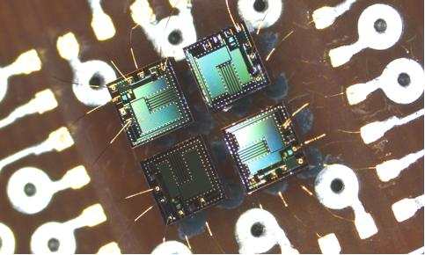

- Wind Sensor Assembly dice (zoomed).

There are six of such assemblies (named Wind Sensor Transducers) per Wind Sensor equipment, each with four dice and each die requiring one control loop. For modularity reasons and backwards compatibility with the REMS ASIC, the MEDA ASIC implements twelve control loops to interface with just three Wind Sensors Transducers.

In addition to acquire the wind sensors information, the ASIC includes up to nine analog channels to interface other type of sensors, like thermocouples, thermopiles or resistance temperature detectors (RTDs). This enhances the ASIC front-end capabilities, expanding the applications range, and covering possible unexpected needs in MARS 2020 or in other future missions.

A digital state machine controls the wind sensor loops and analog acquisitions. It also communicates with the Instrument Control Computer accommodated inside the Rover equipment bay through an UART interface, receiving configuration data for the different acquisition modes, and transmitting the wind sensors and analog acquisitions digitized data. Also, if a SEU is detected, it is reported to the ICU through this serial channel.

MEDA-WS- FE ASIC key features:

- 12 sigma-delta control loops for three wind sensors. 14-bit resolution for 0.5Hz and 1Hz acquisitions, and 13-bit resolution for 2Hz acquisitions.

- 9 analog channels (switchable gain preamplifier + 15-bit ADC) with internal calibration, to acquire RTDs, thermocouples and/or thermopiles.

- Digital machine to configure and control the wind sensor and the analog channels, with SEU detection.

- 19200 baud UART with RS-422 interface.

- Over-temperature protection for the ASIC and the wind sensors.

- Internal housekeeping telemetries: Junction temperature and supply voltage.

The ASIC design have been developed by the Instituto de Microelectrónica de Sevilla (IMSE-CNM) and Crisa, with AMS 0.35 process, using radiation hardened by design technologies. Building blocks and libraries were previously characterized in temperature to -110ºC in the frame of other projects. First ASIC prototypes have been manufactured and started testing in February 2016. ASICs are completely operational and preliminary results are showing to be very promising confirming the expected performances. Once validated, we have the option to go for a second design to foundry iteration, to fine tune and improve functionalities if needed or to launch just the flight lot production.

The ASIC will be packaged by using a high reliability ceramic CQFP-100 package, the same that used for REMS, using a specific process (an adaptation of the standard QML process of the packager company) to make them more robust against the thermo-mechanical fatigue and wear-out effects as did for the REMS ASIC. The ASIC will be afterwards submitted to a full screening and lot qualification process according to EEE-INST-002 “Instruction for EEE parts selection, screening, qualification and derating”

- Wind Sensors Operation
Each Wind sensor operates by heating its four dice to reach the same reference temperature. This is accomplished with four sigma-delta loops sharing a common temperature reference. The ASIC is capable to manage three wind sensors transducers, each with their’s own temperature reference.

The sigma-delta loop is shown in the block diagram of Figure 2. The temperature reference comes from a DAC (not shown), which is common to the three dice of each sensor. The die temperature is measured by its RTD element, and compared with the reference. If the die temperature is lower than the reference, the I_{delta} current (see Figure 2) will be applied to the die heater. Else, the I_{delta} current will be applied to an external resistor through the pin I_{SINK}[n]. In both cases the I_{delta} current source is active, thus achieving a constant current consumption fron the ASIC supply pins. This is necessary, because the ASIC is supplied by the ICU, which is at several meters (4.5m typically) from the ASIC due to MEDA accommodation and rover cabling constraints , so the supply inductance would cause an intolerable voltage ripple if the current consumption is pulsed. Some decoupling capacitors are placed next to the ASIC, but the total capacitance is relatively small due to space constraints, so a continuous current consumption is mandatory.

The I_{base} current source is always active, giving constant heating power. Both I_{base} and I_{delta} are configurable for each die, to optimize the operation of the wind sensor algorithm. This algorithm, which is performed by the ICU, sets the reference temperature and I_{base} - I_{delta} currents, depending on the Martian air temperature.

A 14-bit counter will accumulate the number of heating pulses (I_{delta} pulses) per cycle. From that number, the heating power needed to maintain the die at the reference temperature can be inferred. The integration period for the accumulator is configurable to 0.5s, 1s or 2s. For the first case, the resolution is limited to 13-bit.

Note that the voltage ripple at the die RTD is far below 1mV, so a regenerative microvolt-comparator with auto-zero feature is used.
The finite rise/fall time of the I_{delta} switch may introduce some error in the applied power. For example, if the rise time is faster than the fall time, the applied power will be higher when the I_{delta} pulses are separated than when they are adjacent. If the rise time is slower than the fall time, the opposite will happen. To overcome this, is possible to “cut” the I_{delta} pulses near it’s end, guaranteeing that, if there are N I_{delta} pulses, there will be N rise times and N fall times, regardless if the pulses are adjacent or separated. This refinement is done with an internal “Duty” signal, which can be enabled or disabled, to cut or not cut the length of the I_{delta} pulses.

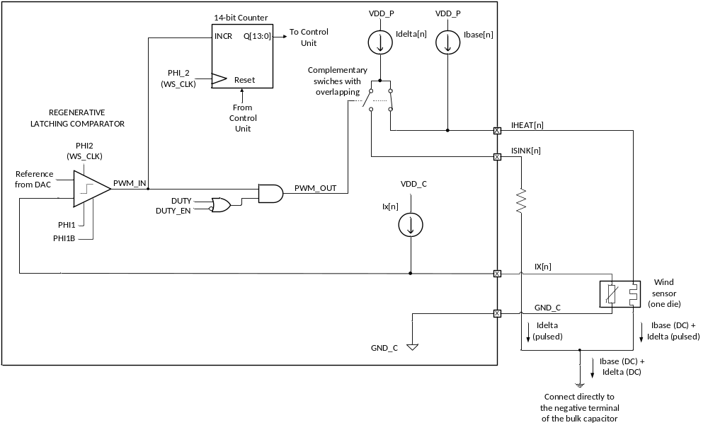
- Wind sensors Sigma-Delta loops

- Analog Acquisition Operation
For the analog acquisitions, a double ramp 15-bit ADC is included. It uses a voltage reference derived from the ASIC’s bandgap reference. This voltage reference implements a curvature correction technique, to compensate the wide operating temperature range of the ASIC.

The ADC is driven by an input preamplifier with two switchable gains: 1V/V and 150V/V. The low gain is used to measure RTDs, and the high gain is used to measure thermocouples or thermopiles. For the RTD measurements, a current source is used. The current value is configurable to accommodate to different RTD types or values.

Both the preamplifier and the current source are multiplexed between nine differential input channels. Each channel can be configured with its own gain and current source value, if applicable. The multiplexing technique, apart from reducing silicon area, guarantees that the characteristics of all channels are equal. Furthermore, as the current source and the ADC are referenced to the same bandgap voltage, the RTD measurements are completely ratiometric, eliminating the error due to the reference. This also happens with the temperature measurements of the sigma-delta reference loop.

Figures 3, 4 and 5 show the ASIC equivalent input circuits when configured to measure two RTD types (Pt7200 and Pt1000), or a thermocouple. Note that for thermocouple measurements, the voltage could be either positive or negative, hence the offset applied to the amplifier. In this figure, there is no cold junction thermocouple. Instead, the connection between the ASIC and the thermocouple wires acts as a “cold” junction (which can be colder or hotter than the called “hot” junction). Actually, the ADC would measure the temperature difference between the ASIC and the thermocouple tip. But the ASIC temperature is always known, because the bandgap circuit gives also a PTAT (proportional to absolute temperature) voltage, which can be captured by the ADC.

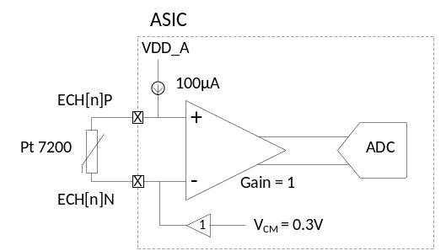

- ASIC equivalent input circuit when configured to measure Pt7200 RTDs.

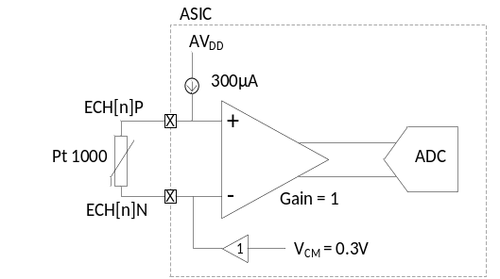

- ASIC equivalent input circuit when configured to measure Pt1000 RTDs.

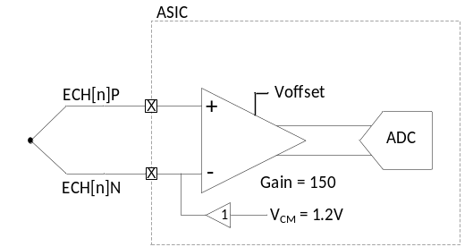

- ASIC equivalent input circuit when configured to measure thermocouples or thermopiles

Apart from the 9 external channels, the ADC is multiplexed to 11 internal signals:

- The output of the three DACs, which set the reference temperatures for the sigma-delta loops.

- A fraction of V_{DD}, to monitor the supply voltage.

- The internal temperature measurement, derived from PTAT signal at the bandgap voltage reference.

- Six calibration voltages, three for the low gain and three for the high gain configuration.

- ASIC Specifications

The key ASIC specifications are detailed in the following list:

- Operating voltage: 3.3V ± 5%. Maximum rating: 3.6V.
- Operation temperature: -128ºC to +50ºC
- Wind sensor loops characteristics:
  - Current source mismatch: ±0.8%
  - I_{base}-I_{delta} compliance: 2.3V
  - Ratiometric measurements
- Analog channels characteristics:
  - RTD measurements accuracy: ±1.9ºC
  - Thermocouple measurements accuracy: ±3ºC for E-type
- Radiation characteristics:
  - TID = 9krad (Si).
  - No Latchup to a LET of 75MeV-cm2/mg.
  - No SEU to a LET of 37MeV-cm2/mg.

The ASIC block diagram is shown in figure 6.

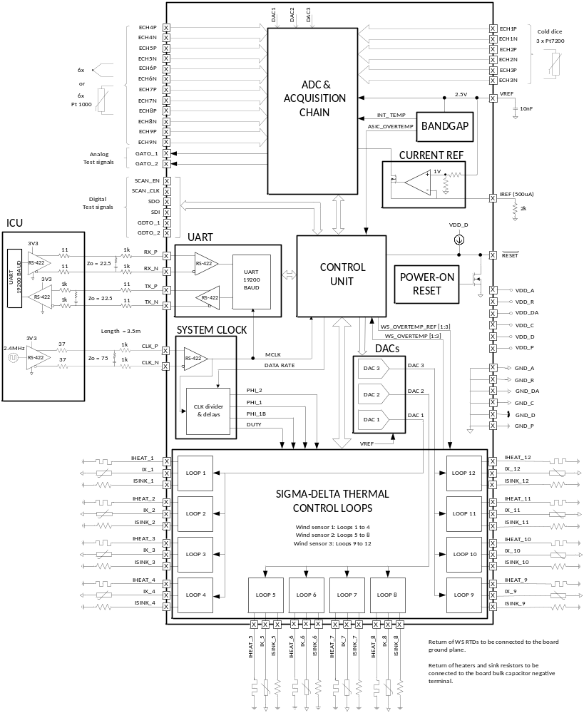

- ASIC block diagram

- Acquisition Board
Each acquisition board is a multi-segment flex-rigid PCB containing one ASIC and three Wind Sensors Transducers. There are two acquisition boards per boom. It also contains the minimum passive components needed by the ASIC: decoupling capacitors, bulk resistors to derive the I_{delta} currents when they are not heating the dice, and a reference resistor to obtain a current reference from the bandgap voltage reference. This current source acts as a master current source, and all the ASIC current sources, including I_{base}’s, I_{delta}’s, and RTD biasings, are mirrored from it.

The acquisition board is exposed to the severe Martian ambient conditions. The passive components have been selected based on their known behavior on extreme temperature ranges (REMS heritage) and are mounted using specific custom techniques allowing them to withstand the thermo-mechanical stresses. Similar approach is followed by the ASIC that is packaged using specific process and materials developed and validated for MSL-REMS and mounted in a very particular way to minimize the thermo-mechanical stresses in temperatures.

Once the ASIC are characterized they will be mounted into their acquisition boards and tested, also in temperature, at Wind Sensor and MEDA levels.

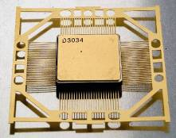

- REMS ASIC package. Same package/same process will be used for MEDA.

- Conclusions and Acknowledge

A new custom mixed ASIC have been designed for withstanding the very harsh Martian environment. It is an enabler of the Mars Environmental Dynamic Analyser research instrument for the Mars-2020 new rover from NASA-JPL. The ASIC developed for MEDA, even being using a new process, is strongly based on the REMS ASIC heritage and technology. Electrical design have been also defined taking into account lesson learns, results and operation constraints from REMS.

The MEDA project is now close to the end of the detail design phase with the MEDA Engineering Model to be manufactured and tested at the beginning of 2017. First ASIC samples have been already manufactured and are presently being characterized electrically and in temperature. Successful results of testing to date allow us to look forward with confidence for the manufacturing and screening and qualification of the flight parts.
Authors want to express their gratitude to the whole MEDA team, composed of many people and many researching and engineering collaborating institutions who are contributing with their time, energy and expertise to make MEDA a reality.
MEDA is a Spanish contribution to NASA. MEDA works to date has been funded by the Spanish National Plan for Space (PNE) depending on the Spanish Ministry of Economy.

- References

- [1] José F. Moreno, Javier Gómez-Elvira, Antonio Peña and Jaime Serrano (May 2009). Data Systems on Aerospace (DASIA) 2009 Conference. The meteorological station for NASA’s 2011 Mars Science Laboratory rover.

[2] Jose-F. Moreno-Alvarez (September 2010). Analog and Mixed-Signal Integrated Circuits for Space Applications (AMICSA) 2010 conference. The Strategy for qualification and mission validation of a mixed ASIC developed for next NASA Mars mission.

[3] Jose F. Moreno-Alvarez, Antonio Peña-Godino, Jose Antonio Rodriguez-Manfredi, Elizabeth Cordoba. Data System in Aerospace (DASIA) 2016 conference (Pending publication).
MEDA, the new instrument for Mars environment analysis for the Mars 2020 mission.

