LVDS: A RAD-HARD Octal 500 Mbps Bus LVDS Repeater for Space
J. Lopezª , E. Cordero^{b}, M. Cirillo^{c}, R. Dittrich^{d} , A. Frouinª, R. Jansen^{d} , D. López^{b}

ªArquimea Ingenieria S.L.U, Spain
^{b}ALTER, Spain
^{c}IHP microelectronics, Germany
^{d}ESA, Noordwijk, The Netherlands

jlopez@arquimea.com
enrique.cordero@altertechnology.com
cirillo@ihp-microelectronics.com
rok.dittrich@esa.int
afrouin@arquimea.com
richard.jansen@esa.int
demetrio.lopez@altertechnology.com

Abstract
Transmission of large amount of data is extensively used in communication among spacecraft and satellite onboard systems during a mission. LVDS (Low-Voltage Differential Signaling) Drivers and Receivers are key devices to provide means of sending/receiving data along twisted pair cable at very high data-rates with low power and excellent EMI performance. Rad-tolerant and Rad-hard ANSI EIA/TIA 644A complaint LVDS Drivers and Receivers products are essential in an extensive range of space applications. Typical applications with such needs are Space-Wire and clock distribution networks.
The purpose of the paper is to present the characterization results performed on the LVDS Octal repeater developed by ARQUIMEA in the frame of ESA’s and ECI’s European LVDS Driver Development intended to be used in space applications and built in IHP’s 0.25-um BiCMOS process technology.
The key features of the octal LVDS repeater include cold sparing, fail safe, more than 250MHz signaling rate per channel allowing above 500Mbps transfer rates over SpiceWire, 3.3V single power supply, low channel to channel skew, TRI-state output control, extended common mode on LVDS receivers.
- Electrical Results
  - General
The Electrical Characterization performed by ALTER on the first manufacturing run of the LVDS octal repeater has mostly fulfilled the specific requirements of the project and the generic Requirements of ANSI/TIA/EIA-644-A-2001 which states Electrical Characteristics for LVDS Interface Circuits.
  - Test Set-up
The set-up includes several channels of high precision power sources that allow high stability supply and precision measurement of all DC parameters of the different inputs and outputs. The test bench includes an LVDS generator and a high bandwidth oscilloscope to measure all AC switching characteristics (See Figure 1).
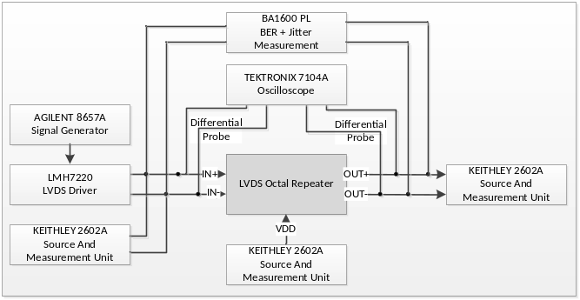
Figure 1: Electrical Characterization Test Set-up
  - Test Board
The Test board uses matched impedance connectors (SMAs) to connect to external test equipment. The signal paths to the connectors are matched in length.
Circuit board layout and stack-up is designed to provide noise-free signals. Ground planes, decoupling, separated high frequency with high level IOs are implemented to minimize unwanted stray noise pickup, feedback and interferences (See Figure 2).
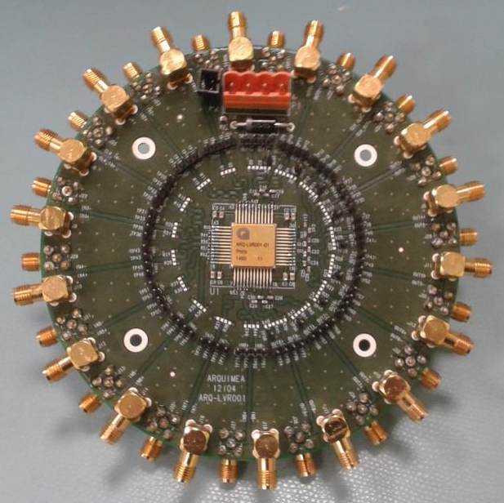
Figure 2: LVDS Octal Repeater Test Board
  - Electrical Parameter deviation
A Non-Compliance-Report has been raised due to the minor deviation on some parameters. This NCR serves as a basis for further improvement of the electrical parameters (See Table1).
- Electrical Parameter Deviations
Parameters | Description | Measured Value | Spec. Limit
V_{TH} | LVDS Input Voltage Threshold | 135mV | <100mV
t_{P} | Propagation time | 5,5ns | <3,5ns
V_{OD} | Differential Output Voltage | 565mV  @-55ºC only | <453mV
I_{CS}  I_{CSOUT}  I_{CSIN} | Cold Spare Leakage currents | 30uA @25ºC  50uA @125ºC | <20uA
I_{OZ} | Output Tristate Current | 15uA | <10uA
J_{RMS} | Jitter rms | 20ps | <15ps

- Radiation Results
  - Total Ionising Dose
    - General
The TID Test was performed by ALTER at RADLAB Facility with a Low Dose Rate of 220 rad(Si)/h up to 300Krad on biased and unbiased samples according to ESCC22900 Standard.
The Octal LVDS repeater did not show relevant degradation of its tested parameters up to 300Krad.
    - Set-up
The samples are located at a calculated distance from the Co60 gamma source to reach the required dose rate in RADLAB Facility as per Figure 3.
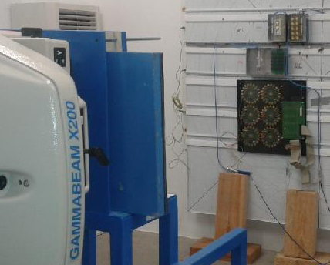
Figure 3: TID Set-up
Pre, intermediate and post-radiation electrical measurements are performed on the components with Electrical Characterization set-up in order to detect eventual drifts.
  - Single Event Effects
    - General
The SEE campaign was performed by ALTER at HIF UCL Facility with Bit Error Rate Calculator and Latch-up protection equipment’s according to ESCC25100 Standards.
The LVDS octal repeater did not show sensitivity to Latch-up at 25ºC and 65ºC up to 62.5MeV.cm2/mg (higher LET applied with Xe ion). The Component is either not sensitive to SET or SEU up to 20MeV.cm2/mg. At higher LET of 62.5MeV.cm2/mg, 15 bit errors were detected after 1E12 transmitted bits.
    - Set-up
The samples are collocated on the Facility frame for Heavy Ion irradiation as per Figure 4. The frame associated with Peltier Modules allows temperature control in order to apply the worst case conditions for the different type of SEE.
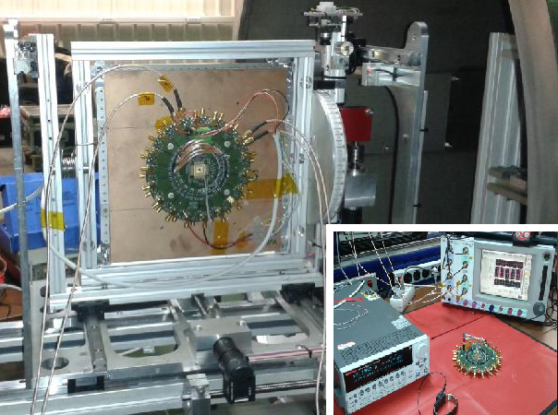
Figure 4: SEE Set-up
During the irradiation, the LVDS Octal Repeater is operating at 200Mbps with all its channels connected in series in order to increase the equivalent number of transmitted Bits.
- ESD results
    - General
The ESD Tests were performed by ALTER in-House with their dedicated Test System according to JEDEC Standard (JS-001-2010, JESD22-A115-A and JESD22-C101-C).
The LVDS Octal repeater withstands correctly the applied ESD pulses:
- HBM ESD model up to ±8KV
- MM ESD model up to ±250V.
- CDM ESD model ±500V
After each pulses levels and combination of pins the protection circuits were tested and BER analysis at 500MHz was performed. No relevant degradation was detected.
    - TLP Results on Wafer
Confidence on ESD robustness of the LVDS Octal Repeater was assumed forehand thanks to TLP ESD characterization performed on wafers by IHP on some ESD test structures developed in collaboration with SOFICS. In fact the LVDS ESD test structure did not show degradation up to 7kV (Highest tested Voltage).
- Further Steps
A few design modifications were required in order to improve the deviated electrical parameters. Specific care was necessary for the selection of a qualified CQFP48 package suitable for space.
The Test Board design is also improved in order to ease the test with removable resistors and increase measurement precision with active probes.
The new LVDS Octal Repeater will now follow evaluation testing according to ESCC2269000 at ALTER in order to give sufficient confidence to reach TLR8.

