Robust CMOS time-based sensor interfaces for space applications
J. Marinª , E. Saccoª, G. Gielenª

ªKU Leuven, Dept. of Electrical Engineering, ESAT-MICAS, Kasteelpark Arenberg 10, B-3001 Leuven Belgium
jorge.marin@esat.kuleuven.be

Abstract
This paper presents an overview of the robustness properties of CMOS time-based sensor interfaces using BBPLL-based architectures, which show a good compatibility with harsh space environments. Two study cases are discussed: a BBPLL-based capacitive sensor interface which can achieve 14-bit resolution using the chopping technique to reduce the effect of 1/f noise, and a fully-differential BBPLL-based resistive-bridge sensor interface that has a very high drift resilience by combining different digitally-assisted techniques. The demonstrated robustness proves that this architecture is a valid candidate for space applications.
- Introduction
Space applications are a growing field, yet the harsh environment of space missions is at the same time a challenging playground for electronic sensor systems. The need for accurate and reliable information about on-board environmental parameters but also about structure sanity, turbine combustion and fuel tank state, among many others, requires sensor systems to be placed in situ [1]. Hence, these robust, reliable and accurate sensing systems are required to operate in hostile environments.
Several harsh-environment-compatible features have already been demonstrated using the BBPLL-based CMOS sensor interface architecture for both capacitive [2] and resistive [3] sensors. The main property of the BBPLL-based time-based architecture is its robustness provided by the direct sensor-to-digital conversion, by means of the time-domain representation of the sensor data. Since the sensor analog signal does not need to be amplified before digitization, area- and power-efficient designs are achieved which are compatible with advanced, highly-scaled CMOS technologies. Additionally, its oversampled conversion provides enough redundancy to filter out in the digital domain corrupted data, produced by analog transient effects such as single-event radiation effects. Another feature is the highly-digital implementation, compatible with digitally-assisted techniques such as time-based signal chopping and differential-path tuning, which can improve the resolution and accuracy performance of the system by reducing the effect of DC and low-frequency perturbations. These techniques can be configured to implement simple built-in self-test strategies that can provide information about the state of the circuit and feed this back for compensation. In such way, smart system-level operation can be achieved by driving capabilities at the local level, for example in the case of wireless sensor networks.
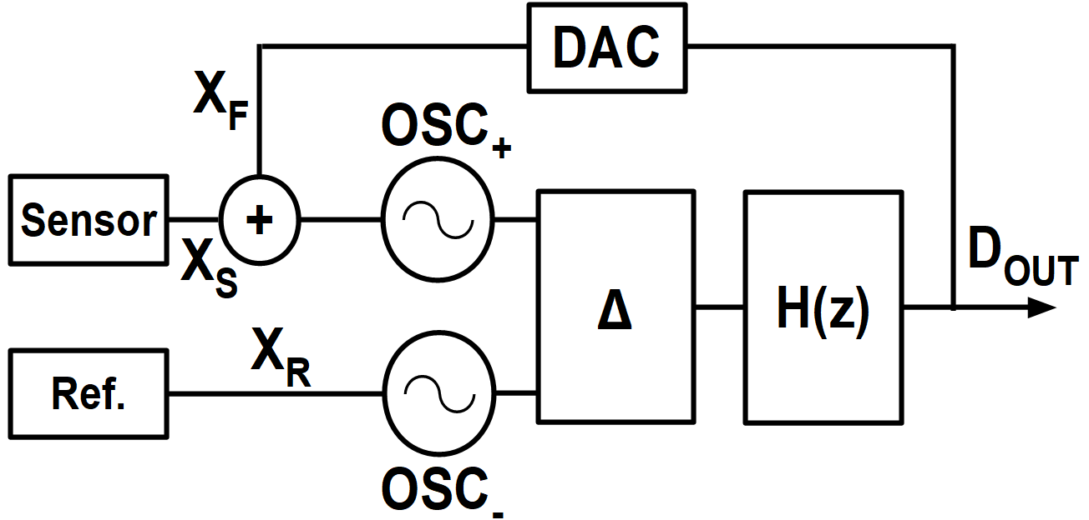
- Block diagram of the BBPLL-based sensor interface
This paper presents an overview of the robustness features that make the BBPLL-based CMOS sensor interface suitable for space applications. Two demonstrator cases are discussed as good examples on how CMOS technologies are used as a low-cost platform for space sensors systems. The first demonstrator is a BBPLL-based capacitive sensor interface which can achieve 14-bit resolution [4]. The interface uses time-domain chopping as the main source of compensation for the oscillator mismatch and the low-frequency noise.
The second interface is a fully-differential BBPLL-based resistive-bridge sensor interface. It provides a very high drift resilience by combining different digitally-assisted techniques [5]. A simple online monitoring technique allows to compensate for sources of drift such as temperature, package strain variations and circuit component degradation. Hence, this interface is suited for harsh environments. The target temperatures in this work, even if not yet the maximum required values for space applications, demonstrate the validity of the principles.
This paper is organized as follows. Section II summarizes the BBPLL-based sensor interface operating principle. In Section III, the main requirements for space application sensors are discussed. The design cases are presented in Sections IV and V. Finally, Section VI concludes the paper.
- BBPLL-based sensor interface operating principle
The time-based BBPLL architecture, described extensively in [6], is depicted as a block diagram in Fig. 1. The BBPLL-based sensor interface architecture uses oscillators to convert an analog sensor signal X_{S} into a digital time-domain signal D_{OUT}. The operation of the system is based on the phase locking of the feedback loop. The sensor value is converted to discrete output changes and propagated through the feedback loop as a feedback signal X_{F} which is added to the input X_{S} each time the phase detector (∆ in Fig. 1) makes a comparison to track the reference value X_{R}. Due to the nonlinear phase detection block, the classical Laplace frequency-domain analysis cannot be used to obtain the system transfer function. Thus, the output reading needs to be obtained by averaging a time-domain train of pulses. To understand the system conversion operation, the time diagram illustrating a simple example is shown in Fig. 2.
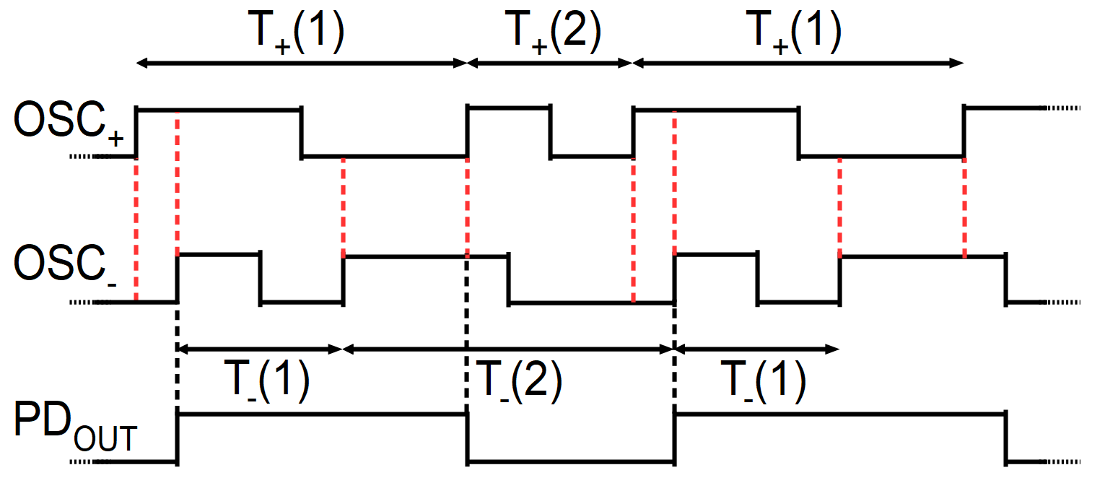
- Limit cycle time diagram of the BBPLL-based interface.
Phase locking produces orbits or limit cycles in the phase plane of the system [7]. In this illustrative example, the minimum number of limit cycle values is chosen for simplicity, i.e. two values, identified as value 1 and value 2. The locking condition implies that the total orbit period of both input nodes is equal:
T₊(1) + T₊(2) = T₋(1) + T₋(2) (1)
The linear oscillator period characteristic T₊ and T₋ as a function of the control variable X (defined by the type of sensor) is written as:
T± = T_{0±} + T_{1±}·X (2)
where T_{0±} is the free-running period of OSC± and T_{1±} is the gain of OSC±.
Assuming matched and period-linear oscillators (T₀₊ = T₀₋ and T₁₊ = T₁₋), the average input variable values of the two oscillators for any number of limit cycle values are forced to be equal:
avg(X_{S} + X_{F}) = avg(X_{R}) (3)
The sensor generates a signal X_{S} = X_{S0} + ∆X_{S} with a base value X_{S0} and a sensor variation ∆X_{S}. If the reference input variable X_{R0} is equal to X_{S0}, then:
avg(∆X_{S}) = -avg(X_{F}) (4)
where X_{F} is an analog representation of D_{OUT} through the DAC, and is expressed as:
X_{F} = LSB·D_{OUT} (5)
LSB is the least-significant value of the DAC. Therefore, the average sensor variation is related to the digital output of the interface as follows:
avg(∆X_{S}) = -LSB·avg(D_{OUT}) (6)
In general, the system needs to be initially calibrated since the LSB value is not accurately known due to process variations, and X_{R0} and X_{S0} can be different due to mismatch effects. Nevertheless, it must be noted that the system transfer function does not depend on the absolute values of the oscillator period, and thus the sensor interface is inherently resilient to the variation of the period value.
- Space sensor interface requirements
The highly-digital sensor interface implementation of Fig. 1 ensures a compact and low-power operation. These are important features required by space devices such as probes, launch vehicles and satellites, since only limited size and weight is available, constraining the dimensions of the power supply elements such as batteries and solar panels [8]. Moreover, self-heating due to poor heat dissipation in vacuum can corrupt the measurement or destroy the circuit [9], which is a reason to minimize the power consumption of the sensor system.
Additional considerations are related to harsh environment requirements, which are highly dependent on the type of mission (date, duration and orbit) [10]. In the hostile context of space applications, the sensor systems need to operate under extreme temperatures, thermal cycling, pressure and radiation conditions. From the point of view of the sensor interface, silicon circuits are subject to drift in their physical properties due to environmental parameters such as temperature and pressure. The latter can also vary with humidity after initial calibration, for example due to changes in package stress [11]. The sensor interface characteristic drift generates an error in the measurements and requires complex compensation procedures (e.g. measuring the source of drift and compensating it using a lookup table) or recalibration [11]. The latter is most often not possible in space applications. Thus, extended operating condition ranges need to be considered during design depending on the type of mission. For example, the International Space Station rule of thumb for temperature extremes in the LEO orbit is in the range between -200°C and 200°C, with 16 thermal cycles per day [12].
The effect of radiation on silicon electronic technologies is divided into two categories: total irradiation dose (TID) and single-event effects (SEE). For digital circuits, different strategies such as added redundancy, layout techniques and architectural adaptations have shown good results. However, analog circuits are more sensitive to errors produced by radiation due to their continuous-time operation. From the modelling point of view, the net effect of TID is equivalent to adding an extra process corner point to integrated circuit variation simulations [13], due to the acceleration of device aging. Thus, this net permanent change in the physical properties of the circuit can in principle be cancelled out by the BBPLL-based interface’s differential structure. On the other hand, the effect of SEEs is a transient charge injection on the circuit’s nodes [14]. Since the BBPLL-based sensor interface is an oversampled system with a well-defined limit cycle for low-bandwidth input signals, the corrupted data due to sudden interruptions in the locked operation can be filtered out in the digital domain.
- Space sensor interface requirements and associated concepts/techniques used in the BBPLL-based architecture
Requirement | Concept/technique
Size and weight | CMOS compact and low-power implementation
Power consumption | Highly-digital low-power architecture
Extreme temperatures | Fully-differential design
Temperature cycles | Time-domain chopping and oscillator calibration
Total irradiation dose | Fully-differential design
Single-event effects | Digital filtering of oversampled data
Degradation (e.g. package stress changes) | Time-domain chopping and oscillator calibration
As mentioned before, the sensor interface output depends on the difference between the oscillator periods, and thus the absolute oscillator period is not relevant. Therefore, the locking condition ensures a good rejection of common-mode perturbations produced by uniform temperature and pressure variations. Furthermore, initial and time-varying mismatch in the differential path, caused mainly by the mismatch between the oscillators’ transfer function, produce gain and offset errors at the system output. The errors are removed by digitally-assisted techniques such as time-based chopping and oscillator tuning, as described in section V. A summary of the space sensor interface requirements and the respective concepts/techniques used in the BBPLL-based architecture is presented in Table 1.
- High-resolution capacitive sensor interface
Accurate and robust sensor systems are essential for the implementation of autonomous systems, which are also becoming more and more important in the context of space applications. In this section, a capacitive sensor interface demonstrator is presented which uses time-based chopping to increase the conversion resolution at low sampling periods, otherwise degraded by 1/f noise produced by the oscillators [4]. The architecture is shown in Fig. 3.

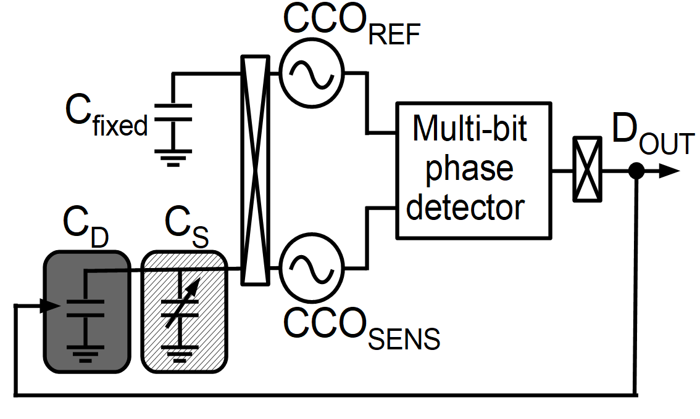
- Block diagram of the capacitive sensor interface [4].
  - Time-domain chopping technique
Traditionally, chopping has been used in the voltage domain as an open-loop dynamic offset cancellation technique that reduces the effect of low-frequency amplifier imperfections [15]. The technique uses modulation to shift the signal to higher frequencies where there is no effect of DC offset and 1/f noise, and then demodulates the signal back to the baseband, upconverting the unwanted part of the signal, that is then filtered in a subsequent stage to recover the original signal with reduced low-frequency disturbance.
Since the 1/f perturbation is contained in the phase of the oscillator in the time-based case, it is possible to make an analogy between the effect of 1/f noise in time-based and in amplitude-based systems. An error is introduced when the phase is compared and thus interchanging the electrical position of the oscillators at the input of the phase detector cancels the undesired 1/f noise otherwise present at the output. This is chopping in the time domain.
  - Simulation and measurement results
The system has been simulated at transistor level in Spectre using a standard 0.18 µm CMOS technology PDK to extract the parameters that represent the nonidealities of the different building blocks. These parameters have been used in a Matlab state variable model to simulate the spectrum of the system output with and without chopping, as seen in Fig. 4.
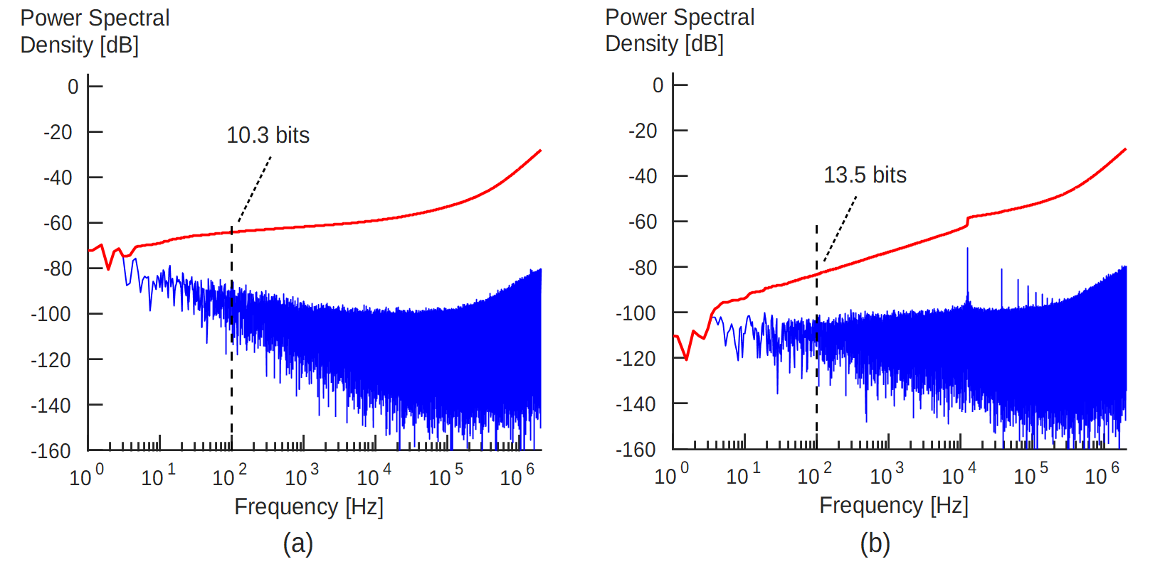
- Simulated SNR for the non-chopped and chopped cases for the capacitive sensor interface in Fig 3.
The simulations show that the 1/f noise produced by the oscillators is modulated to the output, limiting the resolution for high oversampling ratios (OSR) (Fig. 4(a)). The time-based chopping technique attenuates the effect of 1/f noise (Fig. 4(b). In the example, 3.2 ENOB is gained at 100Hz bandwidth thanks to the chopping technique.
The capacitive sensor interface has been implemented in a standard 0.18 µm CMOS technology. The output trace has been obtained for a constant input during 1ms sampling time to calculate the PSD for both the chopped and non-chopped cases. This allow to calculate the SNR at different bandwidths, as shown in Fig. 5. The use of chopping restores the 10dB per decade trend expected from theory. This technique is used in the next section to compensate for drift errors in a fully differential resistive sensor interface.
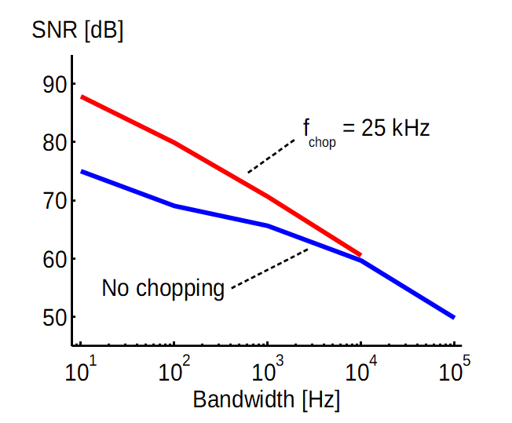
- Measured SNR versus bandwidth for the non-chopped and chopped cases for the capacitive sensor interface in Fig 3.
- Drift-resilient resistive sensor interface
The high robustness requirements imposed by harsh environments in space missions are a demanding challenge nowadays for the design of electronic systems. While the harsh environment operation and stability of resistive sensors has extensively been studied in the last years [16,17], the drift performance of the sensor interface is now a topic of interest. Sensor interfaces condition and convert the sensor signal to the digital electronic domain, and thus their stability is essential for high-performance sensor systems.
In this section, a second proof of concept is presented to demonstrate the drift-resilient capabilities of time-based sensor interface architectures for differential resistive sensors. The architecture is shown in Fig. 6.
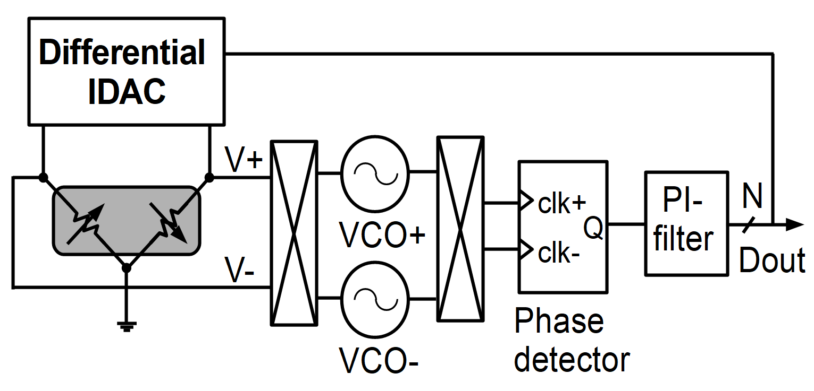
- Block diagram of the differential resistive sensor interface.
  - Drift resilience by design and using digitally-assisted techniques
The presented architecture uses a current feedback bridge to transform the differential resistive bridge sensor values into voltages V+ and V- that drive the two VCOs. In the locked state, the voltages V+ and V- are forced to the same average value by the fully-differential feedback loop, as concluded in section II. Thus, the input-output characteristic is described by the following simple expression:
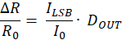 (7)
In case of perfectly matched VCOs, the highly-digital nature of the proposed architecture makes the transfer characteristic dependent on only a ratio of I_{LSB} and I₀. Since highly-accurate and stable current ratios are ensured using current mirrors and common-centroid layout techniques, this architecture is inherently resilient to drift.
However, the mismatch and drift errors in the VCOs produce offset and gain errors in the transfer characteristic. These errors are temperature dependent and cannot be predicted beforehand, requiring time-consuming and expensive calibration procedures.
A method to reduce the above-mentioned errors in a single-temperature calibration is presented in this section. The approach combines two complementary digitally-assisted techniques: VCO time-based chopping and VCO tuning. The first technique dynamically compensates both the gain and offset VCO errors. Additionally, time-based chopping attenuates the effect of low-frequency noise introduced by the VCOs below the chopping frequency f_{chop}, as discussed in the previous section. The second technique reduces the chopping spikes and increases the full-scale range degraded by the mismatch between the VCOs using a VCO tuning algorithm. The method ensures that the initial sensor interface calibration is valid for a wide range of operating scenarios and long lifetime, without the need of additional measurements or offline recalibrations.
  - Simulation results
The state-variable model from [6] is used to simulate the resistive sensor interface system that implements the chopping technique. In Fig. 7, the simulated and analytical model error resulting from VCO free-running frequency error (OST0) and gain error (OST1) are plotted [5]. The normal phase (initial position of the VCOs), the inverted phase (inverted position of the VCOs) and the activated chopping cases are depicted. The plots show that the output errors due to mismatch between the VCO characteristic functions are completely removed by chopping.
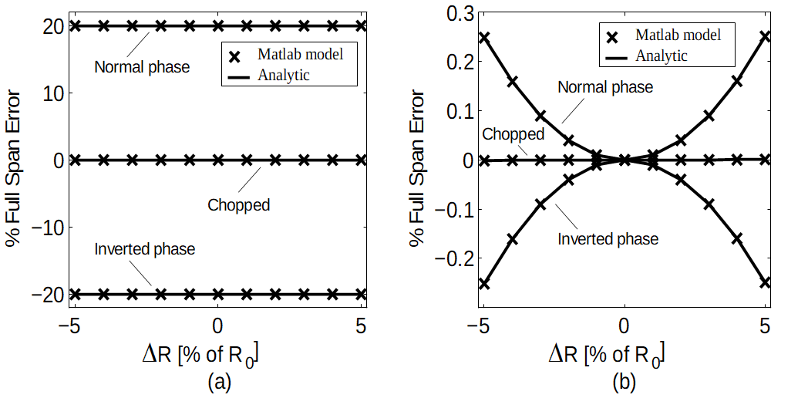
- System output error for (a) a free-running period error OST0 = 1% (with OST1 = 0%) and (b) a gain error OST1 = 10% (with OST0 = 0%).
In Fig. 8, the output error is plotted when a combination of VCO free-running frequency and gain errors are present. The chopping technique greatly mitigates the output error, but it cannot remove it completely. The error is lower than 0.05% of the full scale if OST0 and OST1 are less than 3%.
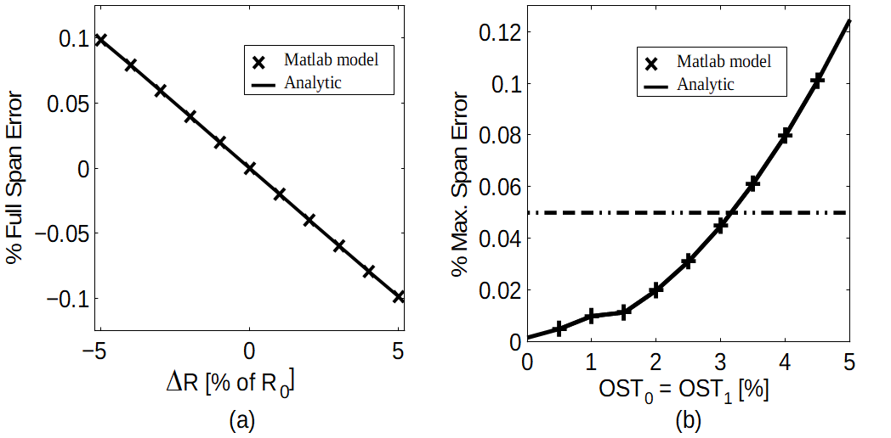
- (a) The error produced by OST0 = 1% and OST1 = 10% using the current feedback is not fully removed by chopping. (b) The maximum output error increases with increasing OST0 = OST1.
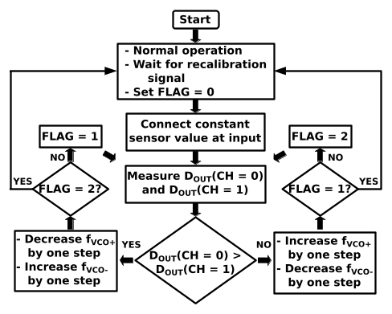
- VCO tuning algorithm flowchart.
To achieve a low drift even in cases in which the error in the differential path increases over time, such as temperature-dependent VCO mismatch, circuit degradation or local permanent radiation effects, the VCO tuning technique is used. The main advantage of this technique in the context of BBPLL-based sensor interfaces is the fact that accurate external references are not needed, since a fixed arbitrary input is enough to determine the error from both chopping phases. In Fig. 9, the tuning algorithm is depicted. A tuning example is shown in Fig. 10, where the tuned condition is achieved after 3 tuning steps.
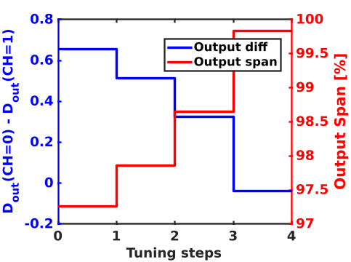
- Output span recovery achieved using the VCO tuning algorithm.
The system has been simulated at circuit level using a standard 0.18µm CMOS technology PDK to verify the performance over a temperature range between -40°C and 175°C. In Fig. 11(a), the free-running average frequency of the VCO is plotted, showing a considerable variation over temperature. In Fig. 11(b), the current ratio I_{LSB}/I₀ present in the system transfer function is plotted, demonstrating the small variation achieved. Very stable current ratios are achieved using proper layout techniques. In Fig. 11(c), the simulated system output error variation with respect to the theoretical equation (7) is plotted, demonstrating a very stable operation over a wide range of temperatures despite the common-mode variations.
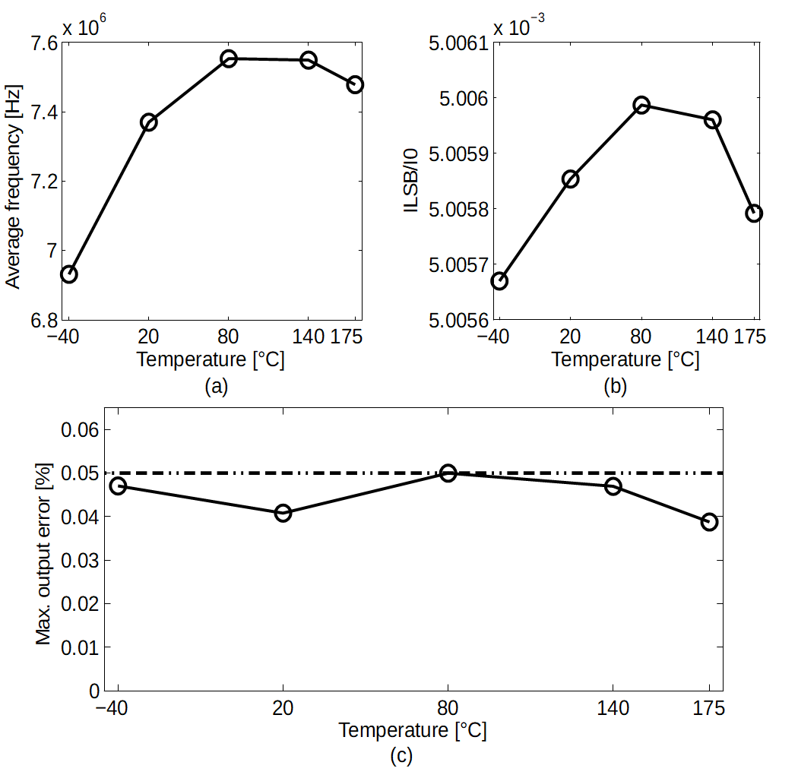
- (a) The VCO locked frequency drifts with temperature. (b) The ratio I_{LSB}/I₀ has minimal drift. (c) The maximum absolute output error of the full system is less than 0.05% over the temperature range between -40°C and 175°C.
Another issue is the nonlinearity at the system output produced by the DAC element mismatch. This issue is attenuated using the dynamic element matching (DEM) technique, which modifies the order in which the DAC elements are used at each clock cycle. This averaging combined with the oversampled operation reduces the effect of the DAC element mismatch. The plots in Fig. 12 show the histogram of the nonlinear output error for a Monte-Carlo run using 1000 samples. The maximum nonlinear error is reduced below 0.05% of the full scale.
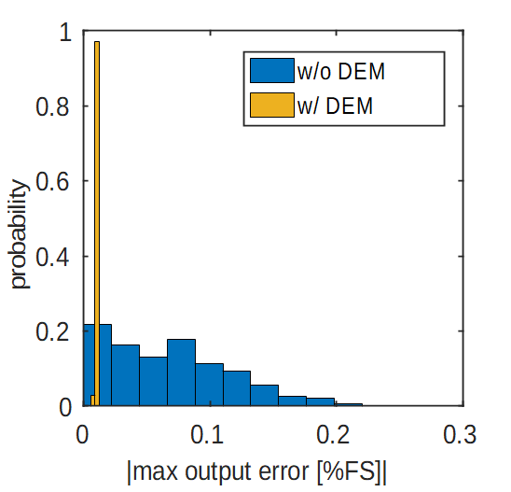
- Histogram showing the maximum output error over the entire input range for 1000 Monte-Carlo I-DAC mismatch configurations without and with DEM using a random error of ±1%.
- Conclusion
The CMOS time-based sensor interface examples discussed have medium-to-high resolution, consume low power and have a small footprint. It results in low-area and low-weight implementations as needed for space applications. Additionally, high robustness is achieved using the BBPLL-based sensor interface architecture with the presented techniques and without a large overhead in power or area. This work constitutes a step towards robust, accurate, light/compact and smart sensor systems that can collect and process high-fidelity data in todays’ space missions.
- References
- G.W. Hunter, P.G. Neudeck, R.S. Okojie, G.M. Beheim, J.A. Powell, L. Chen, "An Overview of High-Temperature Electronics and Sensor Development at NASA Glenn Research Center", J. Turbomach. 2003;125(4):658-664.
- H. Danneels, K. Coddens and G. Gielen, "A fully-digital, 0.3V, 270 nW capacitive sensor interface without external references," 2011 Proceedings of the ESSCIRC, Helsinki, 2011, pp. 287-290.
- J. Van Rethy, H. Danneels, V. De Smedt, W. Dehaene and G. E. Gielen, "Supply-Noise-Resilient Design of a BBPLL-Based Force-Balanced Wheatstone Bridge Interface in 130-nm CMOS," in IEEE Journal of Solid-State Circuits, vol. 48, no. 11, pp. 2618-2627, Nov. 2013.
- J. Marin, J. Van Rethy, J. Vergauwen, G. Gielen, "Digital-domain chopping technique for high-resolution PLL-based sensor interfaces", Sensors and Actuators A: Physical, Volume 249, 2016, Pages 294-302.
- J. Marin, E. Sacco, J. Vergauwen and G. Gielen, "Analysis and modeling of drift-resilient time-based integrated resistive sensor interfaces," 2017 7th IEEE International Workshop on Advances in Sensors and Interfaces (IWASI), Vieste, 2017, pp. 183-186.
- J. Van Rethy, H. Danneels and G. Gielen, "Performance Analysis of Energy-Efficient BBPLL-Based Sensor-to-Digital Converters," in IEEE Transactions on Circuits and Systems I: Regular Papers, vol. 60, no. 8, pp. 2130-2138, Aug. 2013.
- N. Da Dalt, "A design-oriented study of the nonlinear dynamics of digital bang-bang PLLs," in IEEE Transactions on Circuits and Systems I: Regular Papers, vol. 52, no. 1, pp. 21-31, Jan. 2005.
- O. Popescu, "Power Budgets for CubeSat Radios to Support Ground Communications and Inter-Satellite Links," in IEEE Access, vol. 5, pp. 12618-12625, 2017.
- J. R. Jenness, "Radiative Cooling of Satellite-Borne Electronic Components," in Proceedings of the IRE, vol. 48, no. 4, pp. 641-643, April 1960.
- C. Poivey. (2002), "Radiation Hardness Assurance for Space Systems". Available: https://ntrs.nasa.gov/archive/nasa/
casi.ntrs.nasa.gov/20020080842.pdf
- M. Pertijs, "Calibration and Self-Calibration of Smart Sensors", John Wiley & Sons, Ltd, 2014, pp. 17–41.
- M. Finckenor and K. De Groh, "Space Environmental Effects". Available: https://www.nasa.gov/sites/default/files/files/NP-2015-03-015-JSC_Space_Environment-ISS-Mini-Book-2015-508.pdf
- J. Prinzie, J. Christiansen, P. Moreira, M. Steyaert and P. Leroux, "Comparison of a 65 nm CMOS Ring- and LC-Oscillator Based PLL in Terms of TID and SEU Sensitivity," in IEEE Transactions on Nuclear Science, vol. 64, no. 1, pp. 245-252, Jan. 2017.
- M. Mitrović et al., "Experimental Investigation of Single-Event Transient Waveforms Depending on Transistor Spacing and Charge Sharing in 65-nm CMOS," in IEEE Transactions on Nuclear Science, vol. 64, no. 8, pp. 2136-2143, Aug. 2017.
- C. C. Enz and G. C. Temes, "Circuit techniques for reducing the effects of op-amp imperfections: autozeroing, correlated double sampling, and chopper stabilization," in Proceedings of the IEEE, vol. 84, no. 11, pp. 1584-1614, Nov 1996.
- Chien-Hung Wu, C. A. Zorman and M. Mehregany, "Fabrication and testing of bulk micromachined silicon carbide piezoresistive pressure sensors for high temperature applications," in IEEE Sensors Journal, vol. 6, no. 2, pp. 316-324, April 2006.
- Xin Li, Qin Liu, Shixin Pang, Kaixian Xu, Hui Tang, Chensong Sun, "High-temperature piezoresistive pressure sensor based on implantation of oxygen into silicon wafer", Sensors and Actuators A: Physical, Volume 179, 2012, Pages 277-282.

