ASTOS 9.3 - Multibody feature for simulations of flexible launcher dynamics

Valerio Rossi⁽¹⁾, Sven Schäff⁽¹⁾, Sven Weikert⁽¹⁾, Andreas Wiegand⁽¹⁾

(1) Astos Solutions GmbH, Stuttgart (Germany)

Abstract
This work presents the new set of equations of motion incorporated in ASTOS release 9.3.
The new implemented feature, based on DCAP multibody software [1], provides the building blocks to simulate a complete launcher scenario [2] considering vehicle flexibility, sloshing effects, stages separation, engine pressure oscillations and complex aerodynamic loads distribution.
The interaction between those phenomenon and the ascent flight control logic could turn the entire vehicle dynamics unstable. The new functionalities allow ASTOS software to simulate and predict such catastrophic scenarios.
The multibody equations of motion feature let DCAP compute the entire system dynamics while ASTOS provides all the external forces such as aerodynamics, gravity accelerations and actuator output [3].
Five major features are organically embedded in the new MBS capabilities:
- a linear Euler-Bernoulli beam allows to approximate the flexibility and the frequency content of each launcher structure section [4];
- a spring-mass system model allows to simulate the propellant sloshing effect in the launcher tanks [5];
- the transition logic allows to model the separation process during the jettison of exhausted stages by changing the multibody topology;
- separation devices, such as hard-stops and clamp bands, can be employed to reproduce a more realistic scenario during stages disconnections [6];
- engine pressure oscillations effect can be accounted by providing a disturbance loads in time or frequency domain [7];
This work details on each of the above mentioned new functionalities, showing user input and results taken from typical example scenarios.

The work has been performed as part of the ESA project “Advanced modelling of launch vehicles in multibody software” (LauMBS).

ASTOS Overview
ASTOS is a multi-purpose tool for space applications. Originally designed for trajectory optimization, it provides now modules for a variety of analysis, simulation and design capabilities for the whole project life-cycle.

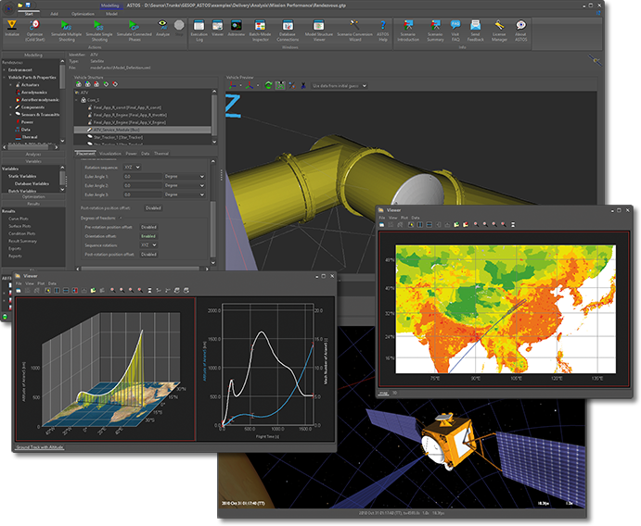
Figure 1: Analysis, Simulation and Trajectory Optimization Software for Space Applications
ASTOS allows to set up arbitrary space scenarios with multiple vehicles, ground stations, areas of interest and points of interest. Each vehicle or station may consist of several structural components, sensors, actuators, etc.
Several customizable models are available for each of the abovementioned categories (model database), as well as for environmental models.
All these models can be reused throughout the scenario using a template approach. A graphical “Vehicle Builder” allows the user to design a spacecraft or a rocket by using the defined and configured elements.
Finally the dynamics configuration, initial states and the translational and rotational motion of each vehicle can be defined.
The standard ASTOS simulation output file already provides several output functions. However, further information can be saved from the simulation result by means of a variety of additional analyses.

MULTIBODY FEATURE Workflow
The new multibody feature allows ASTOS to handle the complex flexible dynamics of multiple bodies systems.
A launcher vehicle is a structure composed of multiple stages and components stacked on top of each other. Such scenario represents a typical multibody system with several parts moving with respect to each other.
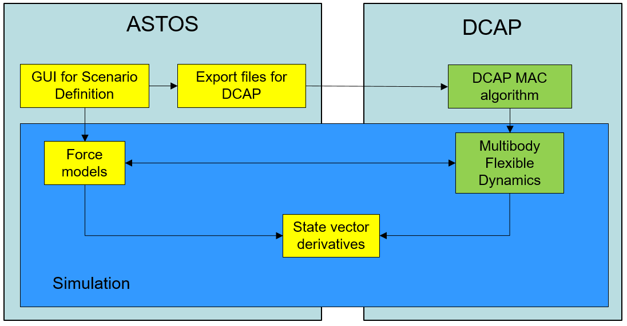
Figure 2: Multibody feature workflow
The multibody equations of motion in ASTOS relay on DCAP software engine, even though the user never interacts directly with this tool.
The link between ASTOS and DCAP is realised through ASCII files for the initialization and through dynamic library interfaces during the actual time simulation.

The user sets up the scenario in the ASTOS GUI by using the “Vehicle Builder” and the dynamics configuration panel.
Once the launcher dynamics is defined, ASTOS exports the DCAP definition files in order to initialize the multibody model. During this phase the mechanical model configured in ASTOS is converted in a DCAP model. Every component, sensor and actuator with mass becomes a body in DCAP. On each body are defined several nodes which represents the attachment points. Finally the hinges link two bodies together, through the attachment points (nodes), in order to generate the multibody chain.

DCAP then generates the equations of motion as auto-coded Fortran subroutines. The equations are later compiled to generate the dynamic libraries required by ASTOS. The open source MinGW environment provides the gfortran compiler used for the compilation and linking processes.
The equations of motion, designed for the specific problem the user wants to analyse and provided as a dynamic library, allow a fast interface with ASTOS.

During run time, DCAP computes the system dynamics and the state derivatives while ASTOS only provides the external forces (gravity, aerodynamics and actuators output) and performs the numerical integration.
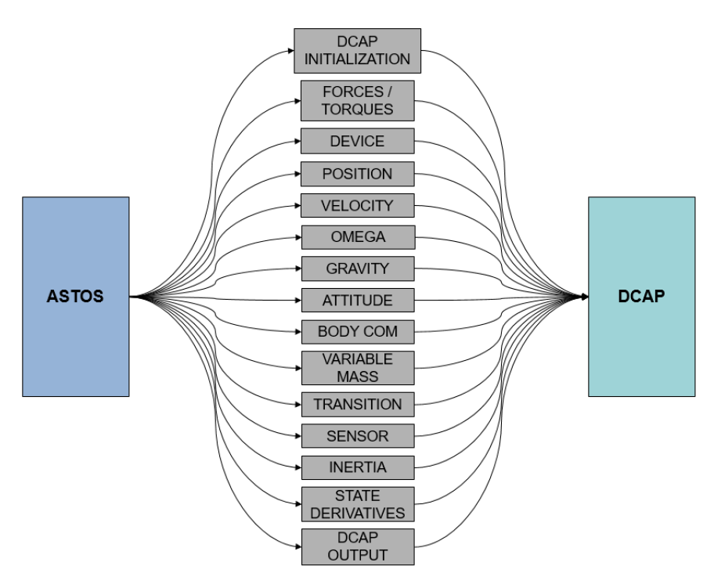
Figure 3: Interfaces between ASTOS and DCAP
Figure 3 gives an idea of how many interfaces are needed between ASTOS and DCAP in order to allow the coupling simulation.
The post-processing of the results is managed in the results viewer as any typical ASTOS analysis.
Figure 2 summarizes the overall workflow of a simulation performed with the multibody dynamics computed by DCAP.

Launcher stage flexibility
Any kind of longitudinal structure experiences a certain deformation under loads which usually cannot be neglected.

A launcher structure is a very long flexible slender beam as shown in Figure 4. The structural deformation and deflection can indeed alter the aerodynamic forces acting on the rocket and the GNC system has to be able to handle those disturbances. Modelling such kind of dynamic effects and disturbances improves the overall launcher simulation reliability [3].
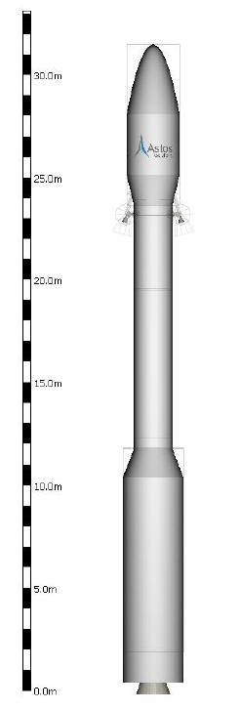
Figure 4: VEGA launcher model in ASTOS
Each launcher components can be defined in ASTOS as flexible. A linear Euler-Bernoulli flexible beam model is used without the need of any external Finite Element Method (FEM) tool. The beam model allows to easily approximate the structural flexibility and the frequency content of the launcher stage.
The user specifies the following parameters from the component settings panel:
- Young modulus;
- damping ratio;
- number of flexible modes.
The beam length, cross section area and the area moment of inertia are automatically computed by ASTOS based on the component geometry. However, those value can also be overwritten by specific user input.
Different configurations of inertia and mass distribution are assumed depending on the propellant type. In case of solid propellant, both the structure and the propellant are considered as one unique flexible body. In case of liquid propellant, only the tank structure is assumed as flexible and the fuel is counted as an additional rigid mass with its own inertia property.
The user defines the flexible properties of each individual component while DCAP makes use of this information to compute the deformations of the entire rocket.

An additional export, for scenarios with flexible multibody feature enabled, allows to compute the frequencies and the mode shapes of the entire launcher at different point of interest during the simulation. This information is usually required for the design of the GNC controller which takes into account also the rocket deformations.

propellant sloshing
Large quantities of propellant can move inside the tanks when the fuel tanks are only partially filled. The lateral dynamic force resulting from the motion of liquids in tanks is known as the sloshing effect.
A strong coupling exists between the sloshing effect, the mechanical structure and the control system. If the frequency bandwidth of the first slosh modes are close to the control system frequencies, the vehicle dynamics could easily get unstable. It is then rather important to account for this effect in a launch scenario simulation.
Complex Computational Fluid Dynamics (CFD) model are not suitable for multibody simulation, especially in the first phases of the vehicle design process. Equivalent mechanical models are much more convenient for these applications [5].
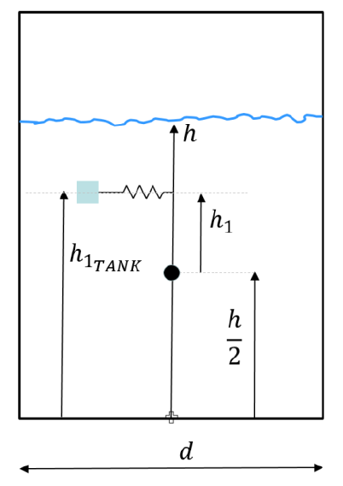
Figure 5: Sloshing model for a cylindrical tank
In ASTOS the user can include the sloshing effect for liquid propellant tank if the multibody feature is enabled. The numerical model is based on a spring-mass system: the fuel is split into one mass rigidly attached to the tank, and one or more moveable masses attached with spring-damper elements to the tank structure, as shown in Figure 5.
For each sloshing mass there are two spring-damper systems acting along perpendicular directions on the normal plane with respect to the tank longitudinal axis. Therefore one sloshing mass accounts for two specular flexible modes and frequencies.
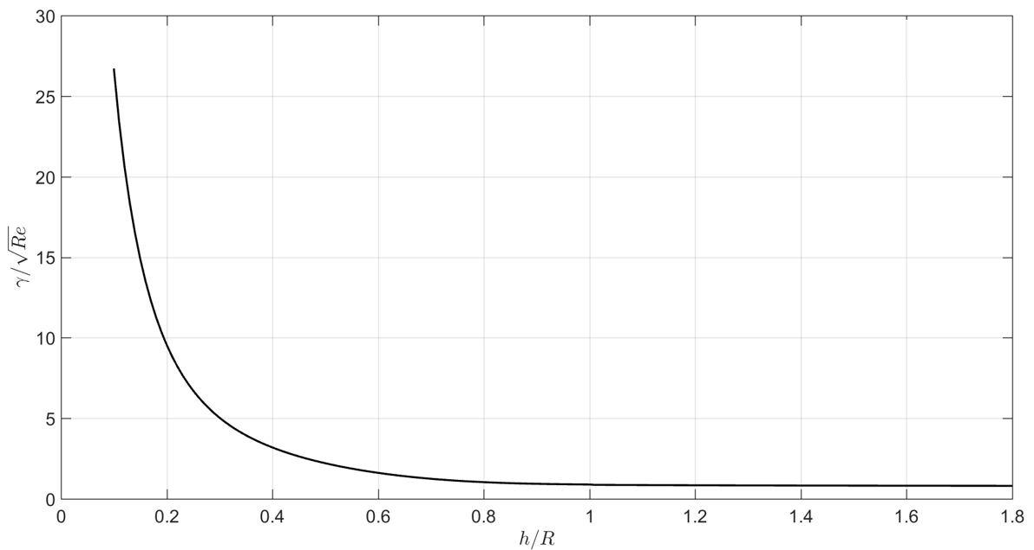
Figure 6: Viscous damping for a cylindrical tank with a spherical dome at the bottom
Figure 6 shows the damping coefficient for a cylindrical tank with spherical domes at different tank fill levels. The parameter h represents the height of the propellant inside the tank and R is the tank radius.
The damping coefficient increases significantly when the tank is almost empty making the sloshing effect quite low.
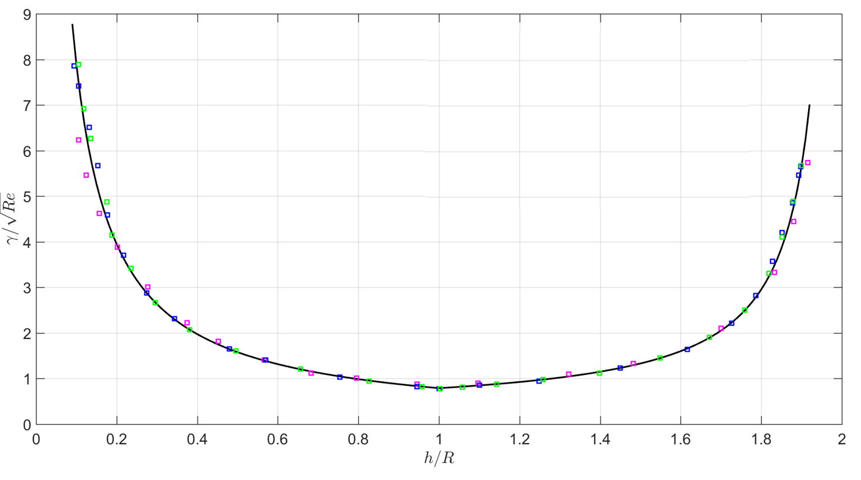
Figure 7: Viscous damping for a spherical tank
Figure 7 instead shows the damping coefficient in case of a spherical tank. In this case, the parameter h spans from 0 to 2R because of the tank geometry. With such geometry the sloshing effect is considerable when the tank is half full, while it is almost negligible when the tank is completely full or empty.

In the ASTOS GUI, the user is required to provide only three high level inputs:
- tank shape: either cylindrical or spherical;
- number of sloshing masses;
- kinematic viscosity of the propellant.

Stages separation
Stages separation in launcher scenarios is one of the most technical challenges to analyse. The separation starts with the disconnection of two components. This process is accomplished by explosive bolts, pneumatic latches or explosive shaped charges.
A later process involves the actuators which actually separate the components. This task is accomplished by retrorockets, pneumatic thruster or elastic spring elements.
These two processes can be easily reproduced in ASTOS by using the new multibody feature.
The detachment process is achieved by releasing the hinge which links the two components and thus by jettisoning the exhausted stage. This phase only involves a reconfiguration of the mechanical system but it does not include any additional separation force.
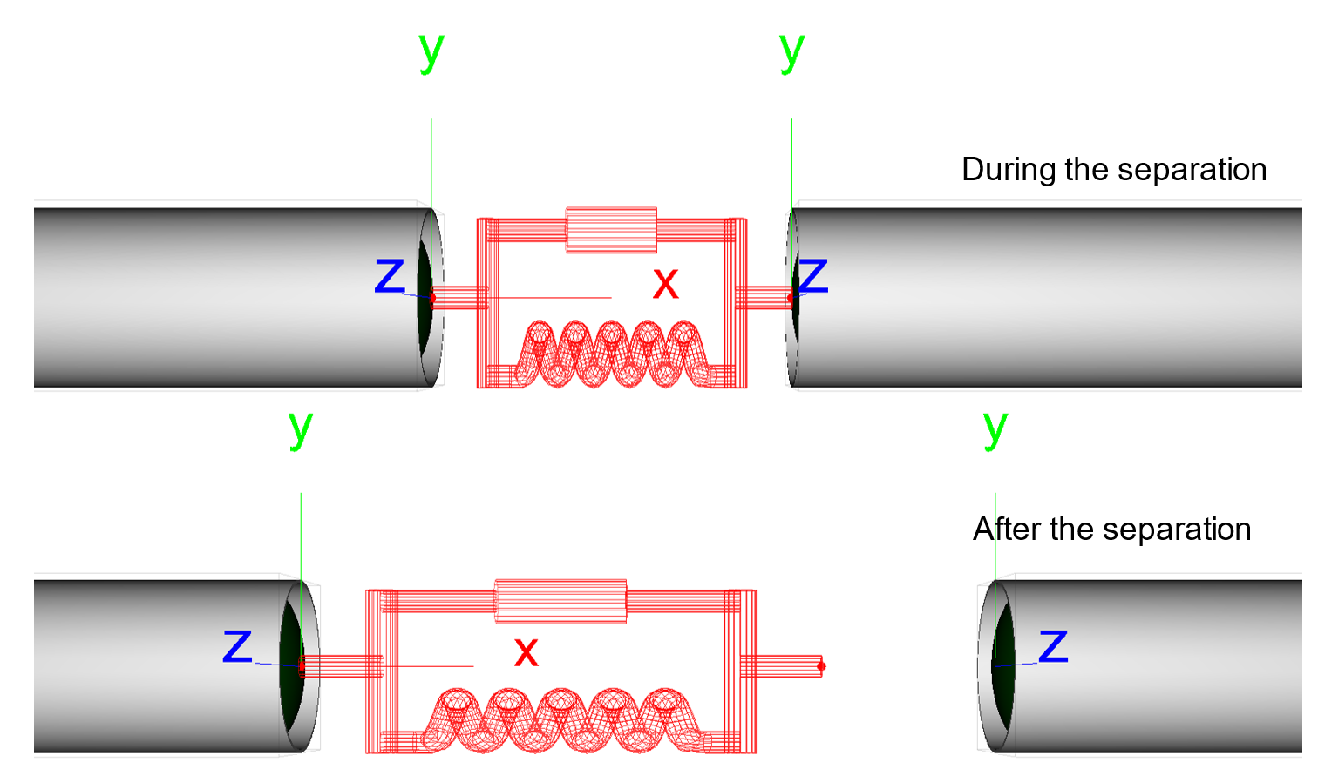
Figure 8: Hard-stop device during and after the separation
Actuators can be mounted between the stages in order to reproduce a realistic separation dynamics.
Three types of separation devices are available:
- thrust force;
- hard-stop device;
- clamp band.
Figure 8 shows the separation process of two stages when a hard-stop device is employed. The spring pushes the stages away until it reaches the maximum elongation and it gets disengaged.
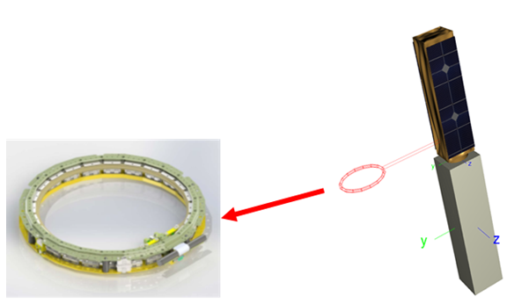
Figure 9: Clamp band actuator
The clamp band actuator is specifically designed for payload deployment as shown in Figure 9. This actuators is made of several equally distributed springs placed along a circumference, reproducing the mechanical system of commercial clamp bands.

In the ASTOS GUI, the user is required to provide only three high level inputs for the clamp band actuators:
- actuator diameter;
- number of springs;
- elastic properties.
In order to achieve an even more detailed analysis, the user can specify the elastic properties of each spring individually. This feature allows to account also for springs misalignment or separation delay.
Figure 10 shows the relative velocity during the separation of a payload and an upper stage. The number of springs clearly affects the separation dynamics.
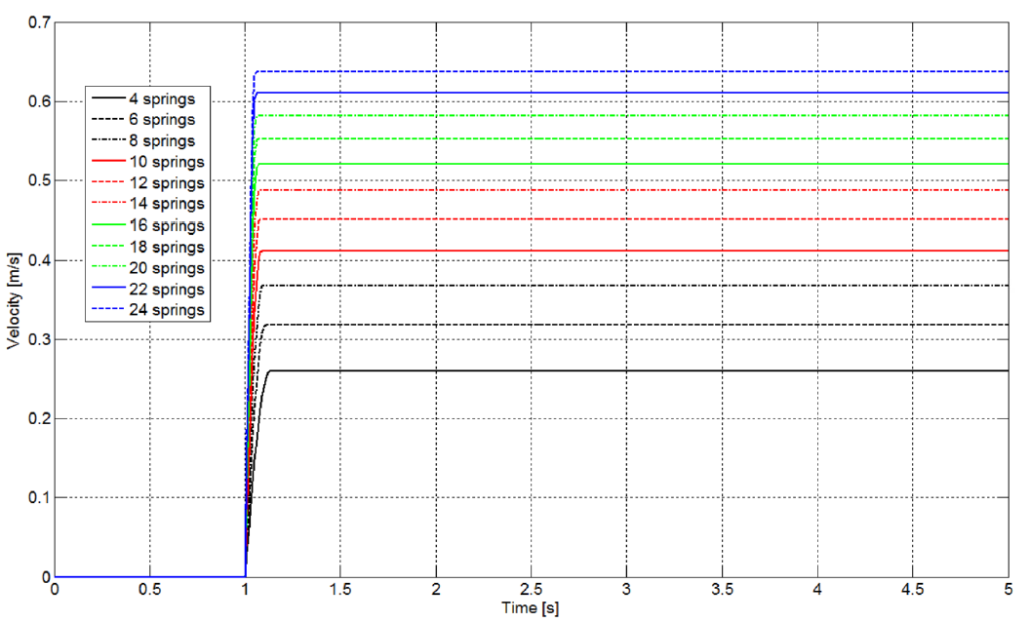
Figure 10: Relative velocity of the payload with respect to the upper stage considering different number of springs mounted on the clamp band

engine pressure oscillations
The operative condition of a Solid Rocket Motor could be characterized by pressure and thrust oscillations [8]. Their frequencies, typically around 50-60 Hz, are usually close to the natural acoustic resonance frequencies of the combustion chamber.
This phenomenon reduces the rocket engine performance and could damage the payload if coupled to the launcher structural modes.
Such kind of phenomenon results from a complex feedback mechanism involving vortex shedding and acoustic resonant mode.
Complex coupled CFD and FEM simulations are needed in order to estimate the frequencies involved. There is no simple equivalent mechanical model available in literature to reproduce such kind of disturbances.
However, if experimental data or simulation results are available they can be used in ASTOS as disturbances and added to the average propulsion profile.
The user can provide two different types of input:
- a force profile;
- a frequency spectrum (in terms of coloured noise).
In the first type, the force profile due to the pressure oscillations is added directly to the mean engine thrust.
In the latter case, the propulsion disturbances spectrum is associated by the user to a coloured noise.
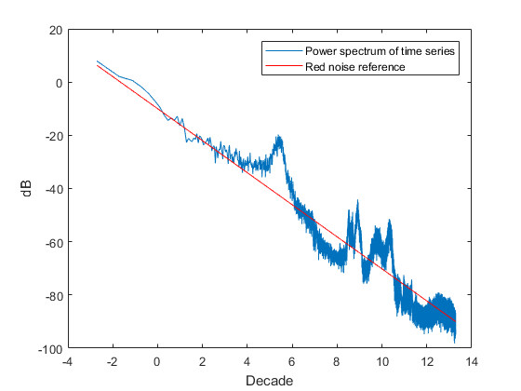
Figure 11: Engine pressure oscillation spectrum
Figure 11 shows a red noise curve with respect to a typical engine pressure oscillation profile.
During the simulation the noise signal is converted into a time domain signal and it is then summed up to the main engine thrust, as shown in Figure 12.
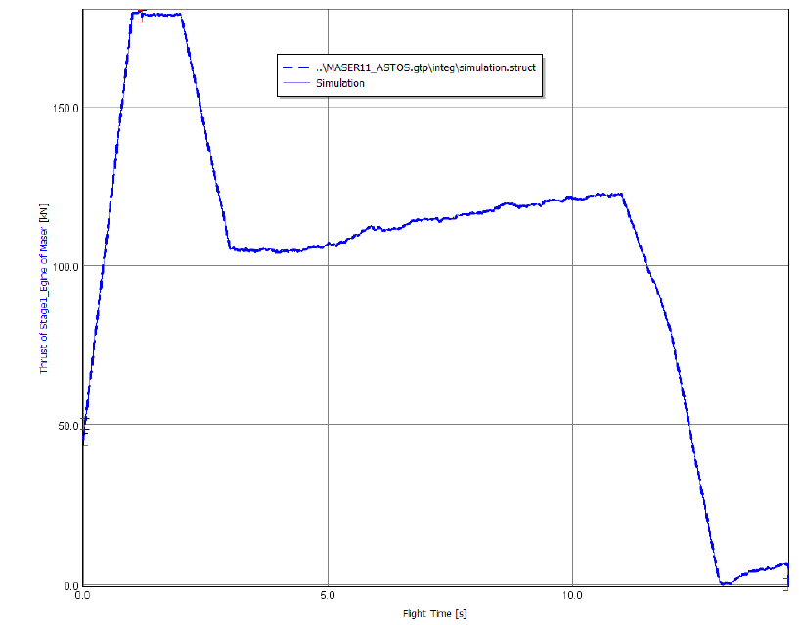
Figure 12: Engine thrust profile with pressure oscillations (red noise signal)

conclusion
The ASTOS release 9.3 significantly extends the capabilities of the software and opens new markets. Although the software started as an optimization tool for launcher trajectories more than 20 years ago, it is nowadays able to perform design optimization, mission performance, system concept, GNC/AOCS simulations, safety analysis tasks and now also flexible multibody simulations.
The new implemented feature opens a multitude of possibilities to use ASTOS for simulations of:
- spacecraft with flexible appendages (solar panels, antennas, …);
- docking of spacecraft;
- towing of vehicles;
- robotic arms dynamics;
- landing scenarios;
A roadmap of future developments is already foreseen in order to improve the component flexible behaviour by importing FEM models directly from the NASTRAN software.
Moreover, a validation of the ASTOS/MBS simulation results with respect to real flight data must be performed in order to increase the software reliability and confidence.

References

[1] | M. Toso, E. Pennestrì and V. Rossi, “ESA multibody simulator for spacecrafts' ascent and landing in a microgravity environment,” CEAS Space Journal, pp. 335-346, 2015.
[2] | V. Rossi, A. Wiegand, S. Weikert, S. Schäff and M. Toso, “LAUMBS: a new software for launch vehicle design and verification during ascent and payload injection,” in ECSSMET, Noordwijk (The Netherlands), 2018.
[3] | F. Cremaschi, S. Winter, V. Rossi and A. Wiegand, “Launch vehicle design and GNC sizing with ASTOS,” CEAS Space Journal, vol. 10, no. 1, pp. 51-62, 2018.
[4] | R. Shuett and B. A. Appleby, “Dynamic loads analysis of space vehicle systems: launch and exit phase,” NASA, 1966.
[5] | F. Dodge, “The New Dynamic Behavior of Liquids in Moving Containers,” Southwest Research Institute, 2000.
[6] | B. N. Suresh and K. Sivan, Integrated Design for Space Transportation System,, Springer, 2015.
[7] | V. Ferretti, B. Favini, E. Cavallini, F. Serraglia and M. Di Giacinto, “Numerical Simulations of Acoustic Resonance of Solid Rocket Motor,” in 46th AIAA/ASME/SAE/ASEE Joint Propulsion Conference & Exhibit, Naschville, USA, 2010.
[8] | P. N. Tengli, “Frequency Analysis of Instability Observed in a large Segmented solid rocket motor,” Journal of Science and Research, vol. 3, no. 1, pp. 65-71, 2012.

