PROMISE, PROgrammable MIxed Signal ASIC Electronics Framework
*Note: Sub-titles are not captured in Xplore and should not be used

Luis Berrojo
Thales Alenia Space
Tres Cantos, Spain
luis-rafael.berrojovalero@thalesaleniaspace.com
Philippe Ayzac
Thales Alenia Space
Toulouse, France
philippe.ayzac@thalesaleniaspace.com
Michael Kakoulin
IMEC
Leuven, Belgium
michael.kakoulin@imec.be
Giancarlo Franciscatto
IMEC
Leuven, Belgium
giancarlo.franciscatto@imec.be
Dimitrios Baramilis
ISD S.A.
Athens, Greece
dbara@isd.gr
Ricardo Póvoa
Instituto de Telecomunicações
Lisboa, Portugal
rpovoa@lx.it.pt
Kari Tukkiniemi
VTT
Espoo, Finland
Kari.Tukkiniemi@vtt.fi
Filip Veljkovic
Thales Alenia Space
Tres Cantos, Spain
filip.veljkovic@thalesaleniaspace.com
Yoan Dupret
MENTA
Montpellier, France
yoan.dupret@menta-efpga.fr
Laurent Berti
IMEC
Leuven, Belgium
laurent.berti@imec.be
Geert Thys
IMEC
Leuven, Belgium
geert.thys@imec.be
Anna Roumkou
ISD S.A
Athens, Greece
aroumkou@isd.gr
Jorge Guilherme
Instituto de Telecomunicações
Lisboa, Portugal
jorge.guilherme@lx.it.pt
Angel Alvaro
Thales Alenia Space
Tres Cantos, Spain
angel.alvaro@thalesaleniaspace.com
Soukaïna Pereira
MENTA
Montpellier, France
soukaina.pereira@menta-efpga.fr
Yaroslav Gubin
IMEC
Leuven, Belgium
yaroslav.gubin.ext@imec.be
Dmitry Arslanov
Alpha-AMSS GmbH
Unterhaching, Germany
dmitri.arslanov@alpha-amss.com
Christos Kordalis
ISD S.A
Athens, Greece
ckordalis@isd.gr
Nuno Horta
Instituto de Telecomunicações
Lisboa, Portugal
nuno.horta@lx.it.pt

Abstract—This paper presents the PROMISE project, that stands for PROgrammable MIxed Signal Electronics. The project has received funding from the European Union’s Horizon 2020 research and innovation program under grant agreement No 870358. It’s tailored to bring to the space community a flexible mixed-signal ASIC architecture design ecosystem built on a portfolio of silicon qualified hardened IP blocks. It includes analogue IPs such as ADC, DAC, PLL, LDO, BG, LO, POR and HV MOS transistors. A digital embedded FPGA core will provide a flexible programmable element and an NVM will permit reconfiguration abilities without the need of using an external memory.
All these elements will be included on a PILOT Circuit ASIC that will be submitted to electrical validation and radiation testing as part of the qualification process of these basic elements for their future use as building blocks.
Keywords—Analogue IP, Embedded FPGA, Mixed Signal, , PROMISE, ASIC, ASSP, Radiation hardening, eFPGA, Non Volatile Memory, ADC, DAC, PLL, LDO, BANDGAP, Local Oscillator, Power On Reset

Introduction
The PROMISE (PROgrammable MIxed Signal Electronics) project gathers IC experts from 7 European institutions. This project has received funding from the European Union’s Horizon 2020 research and innovation program under grant agreement No 870358. It is led by Thales Alenia Space and encompasses diverse European partners, subcontractors, potential users or solution providers, all top actors of the European Mixed Signal ASIC ecosystem. The partners involved are: Thales Alenia Space in Spain (Coordinator), top level SMEs,ISD (Greece) and MENTA (France), key technological institutes such as IMEC (Belgium), IT (Portugal) and VTT (Finland) and a leading satellite manufacturer, Thales Alenia Space in France.
It was launched in early 2020 and is planned to run for 4 years. PROMISE is tailored to bring to the space community a flexible mixed-signal ASIC design ecosystem built on a portfolio of silicon qualified hardened IP blocks. The project is also intended to provide a flexible mixed-signal ASIC manufacturing and qualification ecosystem. Moreover, PROMISE will deliver IP dissemination, commercialization and intellectual property management to allow efficient reuse of the project’s outcomes by the entire space community. Finally, the project will provide a design environment for new IPs and mid-range ASICs for space applications.

Promise Mixed Signal Ecosystem
Space Market is living a mutation with the emergence of ‘New Space’, promoting integration/miniaturization, satellite acceleration, cost-efficient and cost-reduction approaches for all mission types: Earth Observation, Science, Telecom, Navigation and Robotic Exploration. The market for mega constellations is in full swing and several initiatives promoted by different operators are already underway. Accordingly, middle range ASIC solutions are in competition with high performance/high capacity FPGAs, new multicore devices and Rad Tolerant parts and COTS. In particular, Mixed Signal ASIC solutions offer functional added value for testability of electronic units and digitalization of full analog functions. The PROMISE project objectives are to optimize the design cost, shorten schedule and de-risk analog and mixed signal ASIC radiation hardened design, manufacturing and qualification according to the needs of the space industry.
PROMISE shall specify a modular architecture based on the DARE180X/XFAB XH018 0.18 micron Mixed Signal HV CMOS Technology that allows the end users to target both simple and complex applications of Mixed-Signal ASICs such as signal conditioning and acquisition, motion control, signal processing, signal synthesis and others. This architecture will pivot around a central eFPGA module that shall provide extra flexibility during the lifetime of the mixed-signal ASIC.
PROMISE shall design an IP library oriented towards the fast design of mixed-signal ASICs by the suitable aggregation of pre-validated modules with the minimum added specific circuitry. It will enable mixed-signal ASIC and ASSP approach. IP reuse will ensure a shortest and secured schedule and de-risk the design hardening for mixed-signal ASIC/ASSP.
As first population for this library, based on the proposed architecture, PROMISE shall design a set of Radiation hardened and reusable analog, high voltage and digital IPs that will cover the most common functions for data acquisition, conditioning, processing and control. The proposed initial portfolio of IPs shall cover, at least, the following functions:
- Digital IPs: Standard digital cells ; Standard digital IOs; Non-Volatile Memory (NVM); Embedded Field Programmable Gate Array (eFPGA) core.
- Analog IPs: Analog to Digital Converter (ADC); Digital to Analog Converter (DAC); Phase Locked Loop (PLL); Low Drop Out (LDO) for digital core; BandGap (BG) with second order temperature compensation; Local Oscillator (LO) with no external component and consistent with CAN bus; Power On Reset (POR); High Voltage MOS transistors (HV).
This project has received funding from the European Union’s Horizon 2020 research and innovation program under grant agreement No 870358
All IPs shall be compliant with the radiation requirements defined within the project. The target radiation performances to be tested on a PILOT Circuit ASIC are as follows:
- TID: > 100 Krads
- SEL: LET > 60 Mev.cm²/mg
- SEFI: LET > 60 Mev.cm²/mg
- SEU: < 10⁻⁸ event/day/bit
PROMISE shall generate a library of IPs ready to be integrated into fully functional mixed-signal ASIC designs including the Qualified Radiation hardened IPs: digital, analog and high voltage MOS transistors. A PILOT Circuit ASIC design integrating the full set of IPs will be used for performing the Electrical validation and characterisation of the IPs. It will also allow testing the radiation performances of the constituent blocks. Validation and Qualification of the IPs will pursuit the following targets:
- Measured Electrical compliance of the IP blocks through the electrical validation of the Pilot Circuit;
- Get the electrical Safe Operating Area for high Voltage MOS;
- Evaluated Radiation hardness of the IP blocks through the radiation evaluation on the Pilot Circuit.

PROMISE Pilot Circuit ASIC Architecture
The PROMISE Pilot Circuit will be the demonstrator for the ASSP approach enabled by the radiation hardened PLL, eFPGA and NVM. The design phase is in progress and the simplified top level synoptic is can be found in Fig. 1
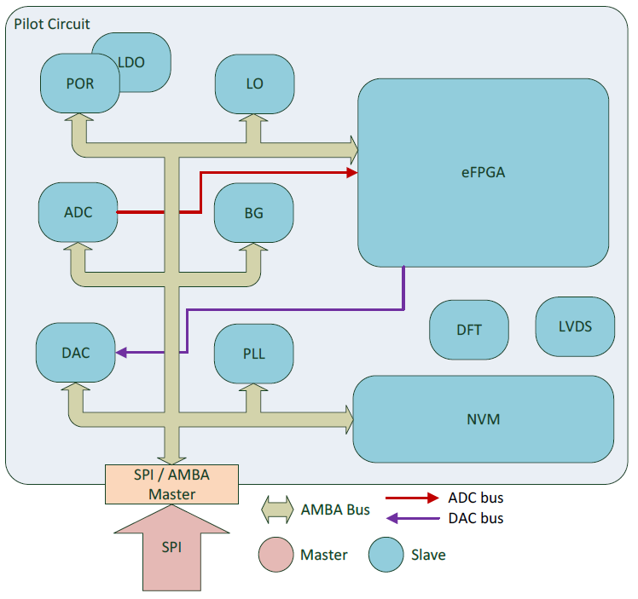
- PROMISE Pilot Circuit diagram
PROMISE Pilot Circuit will instantiate all the IPs designed and radiation hardened by the PROMISE partners during the project. The digital core will be designed using the existing DARE180X standard core cells, level shifters and IO cells radiation hardened libraries.
The POR, Bandgap, LDO and Local Oscillator will ensure the safe power up of the circuit. ADC and DAC are intended to provide analog resources for housekeeping acquisition and sensor or actuator biasing. SPI interface will provide user interface via an AMBA bus. The NVM will embed Pilot Circuit configuration bits and the eFPGA bit stream. The eFPGA provides GPIO and the LVDS IOs will be implemented for characterization. Standard digital DFT (SCAN) is implemented and internal analog points are available through a specific analog test bus per power domain (3V3 and 1V8).
All IPs can be accessible and operated individually to ease the debug and characterization tests. The Pilot Circuit will also embed high voltage test features (MOS, Bipolar and diodes)
Most of the IPs are under design, except standard cells, IOs and eFPGA which already available. The following table summarizes the IP owners:
- IPs and owners
Company | Function/IP
MENTA | eFPGA
IMEC | NVM, digital libraries
ISD | ADC, DAC, PLL, LDO
IT | Local Oscillator, Bandgap
VTT | Power On Reset
TAS-France | Pilot Circuit Front-end and Synthesis
IMEC | Pilot Circuit Back-end
TAS-Spain | User application in eFPGA

The PROMISE Pilot Circuit will manufactured by XFAB foundry using a Multi-Layer-Mask reticle and will be packaged in a CQFP352 shown in Fig. 2.
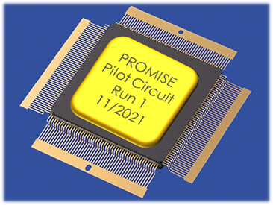
- PROMISE Pilot Circuit package
The PROMISE Pilot Circuit is under design and will support the electrical and radiation tests for design validation and silicon level qualification for all the embedded IPs.

IP LIBRARY OVERVIEW

eFPGA IP
Menta is the proven eFPGA pioneer whose design-adaptive standard cells-based architecture and state-of-the-art tool set provides the highest degree of design customization, best-in-class testability and fastest time-to-volume for SoC design targeting any production node at any foundry.
For PROMISE, Menta is providing a radiation hardened embedded FPGA (eFPGA) IP [1], that will be integrated into PROMISE ASIC design architecture, enabling hardware re-configurability in the field.
After a first successful phase of collaboration with IMEC, that led to a set of optimized radiation hardened standard cells for best PPAs (Power, Performances, Area), Menta has successfully delivered on schedule to the PROMISE project, its radiation hardened embedded FPGA (eFPGA) closing CDR (Critical Design Review) Milestone. IP will now be integrated in PROMISE Pilot Circuit.
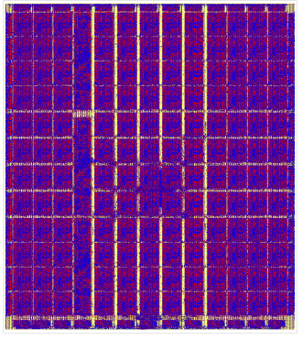
- PROMISE eFPGA IP top level GDSII
- eFPGA IP of 1750 LC (capacity similar to Microsemi RTSX32) + 3 additional DSP
- IP technology is XFAB 180 nm (XH018)
- Radiation -hardened
- eFPGA IP is designed 100% using DARE180X heritage and PROMISE rad-hard standard cells designed by IMEC.

Non-volatile memory IP
Non-volatile memory (NVM) macros are widely used in digital circuits in order to store instructions, user data or any configuration data. In PROMISE, the NVM macro keeps the user defined FPGA configuration data. FPGA consists of multiple LUT instances. In general, every LUT has configuration signals, which define the logic function a LUT performs. At the same time the set of those configuration signals defines a particular user functionality of FPGA. In PROMISE FPGA, the configuration data are uploaded at power up from the NVM to the LUT registers. Obviously NVM has a data capacity equal to the amount of FPGA configuration signals plus redundancy bits required by the radiation hardening technique.
NVM macro designed in PROMISE will be based on SONOS cell of E2PROM type offered within 180 nm HV CMOS process. This cell promises a satisfying level of robustness against TID effects. E2PROM type write/erase operations provide reliable data retention parameters. The cell endurance (amount of erase/write cycles) is worse than in FLASH cell type, but the target application does not require high endurance. NVM memory will be hardened against SEL and SEU/SET by use of standard DARE RH mitigation methods. On top of that error correction codes (ECC) with single error correction double error detection (SECDED) capabilities will be implemented as SEU mitigation method. ECC improves also the general read robustness of NVM and thus is highly required in space applications, different types of error correction codes are described in detail in [2]. As a result, the NVM macro will operate as a robust and radiation hardened data storage IP.
NVM macro will have 344 kbits user data capacity and will be organized with 32 bit data words, where 24 bits are user data and 8 bits are ECC. It will be split in 2 banks with 32x22 pages. Every page consists of 8 words. The memory organization parameters are provided in Table 1. NVM will have standard synchronous parallel user interface which simplifies read operations. NVM will have a built-in Charge Pump, as well as all control logic to perform erase/write operations following a user instruction. Various test modes will be implemented in NVM macro to support a production test flow. Power down mode is another memory feature which allows to reduce the overall system power consumption once configuration data are uploaded. The memory macro requires 2 supply voltages: 1,8V and 3,3V with ± 10% tolerance.

- NVM IP general parameters
Word, bits | 32
Number of Data Words | 256x42
Total Number of Words | 256x44
Page, Words | 8
Pages per Sector | 32
Number of Sectors | 42+2 inactive
Memory banks, | 2
Sectors per Memory Bank | 21+1
ECC Bits per Word | 8
Total Amount of Memory, bits | 360448
Synchronous Parallel Interface | Yes
Data I/O Width, bits | 32

The NVM is under design.

Digital Libraries
Digital libraries in DARE180XH platform [1] support the implementation of mixed-signal designs for space applications in the low-power XFAB 0.18µm commercial technology. Special layout techniques are employed to reach TID tolerance over 100 krad as well as SEL hardening against events over 60 MeV/cm2.mg. SEE hardening can be achieved at system level by combining SEU-hardened architectures and hardened-by-drive-strength cells available in libraries using unique design methodologies.

DARE180XH features extensive standard cell libraries in low-power and low-Vt device flavours, multi-domain I/O library for analog and digital interface and a range of SRAM memory blocks. Recent developments include optimization of SEU-hardened DICE cells to tackle charge sharing effects under transient events, additional 1.8V analog I/O cell configurations, a distributed power-on-control mechanism in I/O cells and a new power management kit (PMK) library to enable interfacing 3.3V logic from mixed-signal IP and 1.8V standard core logic.

The DARE180XH_LVDS library include a LVDS receiver and a LVDS transmitter. The LVDS library will provide a high speed data rate with up to 700 Mbit/s. This library is fully cold-spare compliant as required by most of the space application. Both can be biased in current when a limited number of LVDS IOs are needed or in voltage when an important number of LVDS IOs must be instantiated. The LVDS receiver has also a fail-safe output that can be used to monitor the line connection (to detect a short or an open default). Both have been designated to be SET free till 60 Mev*cm2/mg and SEL free till 80 Mev*cm2/mg.

24 bit ADC IP
The system block diagram is shown in next figure :
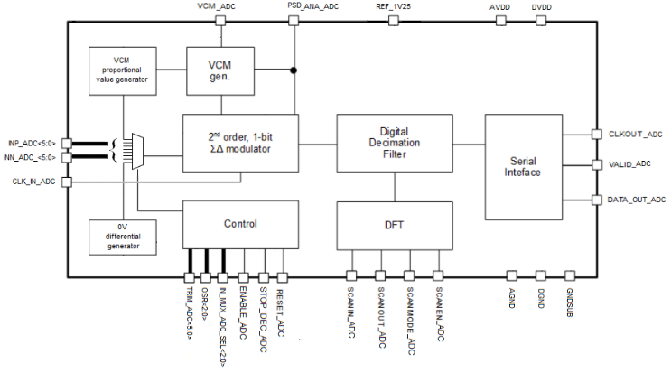
- 24 bit ADC block diagram
The ADC architecture is based on a second-order, discrete time (switched capacitor) Sigma-Delta modulator with 1-bit quantizer [4]. The ADC has 6 differential multiplexed inputs that enable interleaved data acquisition and two dedicated inputs for offset and gain correction. The full-scale input voltage range is a multiple of the 1.25V bandgap generated reference voltage and equal to ± 2.5V, which can be trimmed externally at 6 bit resolution The differential input voltage is modulated by the ΣΔ modulator operating at a maximum frequency of 15MHz with selectable Over Sampling Ratios from 64x up to 2048x. The output data are provided through an SPI like 3-wire synchronous digital interface in signed binary format.
The targeted main specifications are listed in TABLE III. TABLE III.
- ADC Targeted Specifications
Conditions | Conditions | Value | Units
Full scale range (FSR) |  | ±2.5 | V
Analog input bandwidth | OSR = 256x | <40 | kHz
Offset |  | <1% | FSR
INL |  | <1.5 | LSB
DNL |  | <1 | LSB
Gain Error |  | <0.25% | FSR
ENOB | At 256 ksps | 15 | bits
Power consumption | At fclk=15MHz | 45 | mW

The ADC is in the schematic finalization stage.

24 bit DAC IP
The Digital-to-Analog converter is a current-steering, low-noise circuit optimized to operate in the frequency range between DC and 50kHz [4]. The DAC receives 24-bit sampled data in a synchronous serial format and converts it into a differential current analogue signal. It uses a third-order multi-bit Sigma-Delta modulator. The embedded interpolator follows a multiple-stage architecture and consists of an FIR equi-ripple low-pass filter followed by two cascaded stages of Half-band equi-ripple filters. The last stage is a programmable SINC filter, which provides variable interpolation ratios allowing sampling rates as high as 310kHz. The system operates on a single clock domain, which is provided externally. The output current matrix features a Return-to-Zero (RTZ) technique to improve the linearity by ensuring that each elementary current source is zeroed, regardless the data value of the sample sequence. The internal reference current can be trimmed to achieve accuracy of less than 1 % of the Full Scale Current (5.5mA). The use of an external current reference is supported as an optional feature. The reconstruction filter and the I/V converter are realized externally to aid the design flexibility and device integration according to the target application requirements. The system block diagram is shown in Fig. 5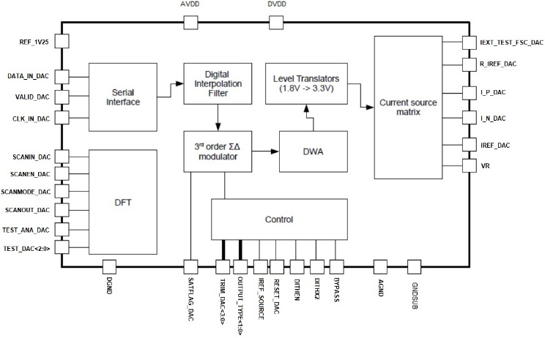
- DAC block diagram
The DAC is at the schematic finalization stage.

PLL IP
The system block diagram is shown in Fig. 6
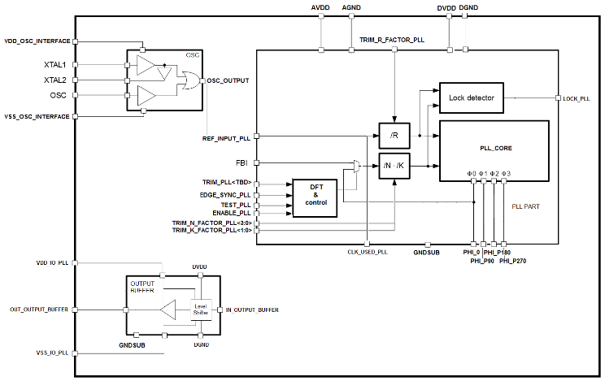
- PLL block diagram
The PLL is built around a multi-phase VCO core capable of generating very stable clock signals up to 200MHz in frequency that are locked in phase to an externally provided, or to an ASIC’s internal generated, clock reference source running at a much lower frequency [4]. The external reference clock input maybe directly interfaced to a 3.3 LVTTL digital source or a sine wave oscillator in the frequency range between 8 MHz and 50 MHz. Alternatively, the reference clock can be locally generated by a quartz crystal attached directly to the crystal interface input of the PLL using a minimum number of external components. The supported reference clocks are from 8 MHz up to 50 MHz. The PLL can generate simultaneously four different phased clocks signals at 0o, 90o, 180o and 270o phase shift related to the rising or falling edge of the reference clock.
Key target performance is the peak-to-peak jitter to be less than 20ps at 200MHz. The PLL start-up time, until the Lock flag is asserted, shall be lower than 100μs. An integrated output buffer will be able to drive 50Ω transmission lines at 3.3V LVCMOS/LVTTL levels through external source series resistive termination.
The PLL is at the schematic finalization stage.

1.8V LDO IP
The system block diagram is shown in next figure :
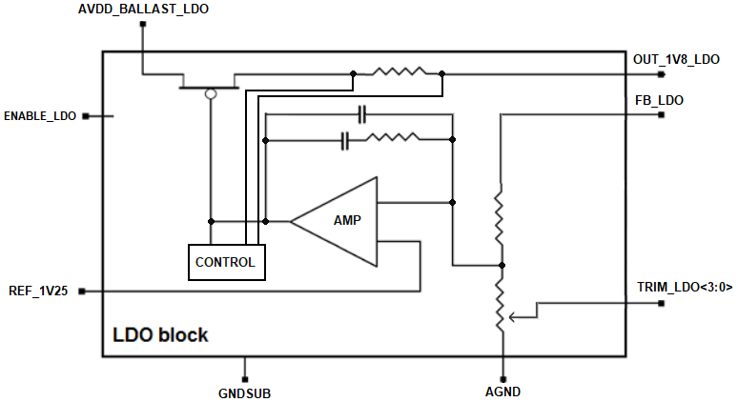
- LDO block diagram
The LDO generates from the 3.3V supply rail the lower 1.8V supply voltage needed by the digital circuits within the ASIC [5]. Its output voltage can be fine-tuned through an external digital discrete interface at 4 bits resolution. The LDO includes short circuit protection and enters a safe mode when the current through the integrated series shunt resistor passes a fixed threshold limit. It remains in this state until the built-in over-temperature protection function is activated, which inhibits the operation of the LDO as long as this fault state is sustained When the junction temperature recovers within the safe operating levels, the LDO operation is automatically resumed.
The output voltage of the LDO never exceeds ± 10% of its nominal value, even during extreme load transient conditions including 0-100% output load steps and vice versa. During start-up and following an over-temperature recovery event, the built-in soft start operation is activated that reduce the in-rush current transients. The feedback monitoring resistor divider is not tied internally, for more accurate load regulation.
The LDO is at the schematic finalization stage.

Bandgap IP
Bandgap Voltage Reference (BGR) circuits are widely used in analog and mixed-signal intellectual properties, in pilot circuits, balancing proportional-to-absolute temperature and complementary-to-absolute temperature voltages, in order to deliver a stable and temperature-independent output voltage [6].
In PROMISE, the BGR has a 2nd-order curvature compensation and is capable of delivering, not only a stable output voltage, but also current sourcing for N-type and P-type loads through internal resistors or, optionally, through an external precision resistor.
The BGR design includes 8-bit trimming resistive ladders for post-fabrication calibration in temperature compensation slope, absolute output voltage and absolute output current. The applied technique is essential to perform in all the special conditions that characterize the space environment, while considering process, voltage and temperature variations, as well as the impact of Single-Event Transients (SETs) and Total Ionizing Dose (TID) [7][8].
The BGR block diagram is shown in next figure :

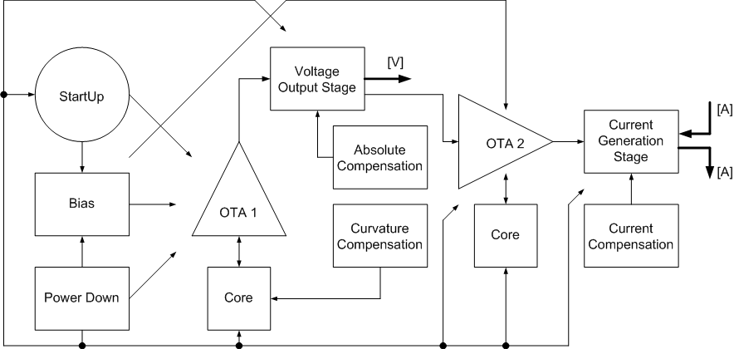
- Bandgap block diagram
The circuit was designed in a 180 nm Silicon-on-Insulator CMOS technology, using radiation by design technics. A temperature coefficient better than 8 ppm/°C (6 Ω/bit) over an extreme temperature range of -40 to 125 °C has been achieved in simulation, with a 1.25 V output voltage and 20 μA output currents after calibration, draining less than 1 mA from a 3.3 V source, as outlined in next table :
- Bandgap Simulation Results Summary
Output Reference Voltage  [V] | Ouput Reference Current  [μA] | Analog Supply Voltage  [V] | Digital Supply Voltage  [V] | Current Consumption [mA] | Temperature Coefficient [ppm/°C] | Power-Supply Rejection Ratio [dB]
1.25 | 20 | 3.3 | 1.8 | < 1 | < 8 | > 60

The BANDGAP is at CDR stage.

Local Oscillator IP
Quartz crystal (XTAL) resonator and crystal oscillator (XO) are widely used as a frequency reference in numerous applications. Despite XTALs and XO being excellent frequency references due to the intrinsic high quality (Q) factor, high frequency accuracy and low frequency temperature coefficient, both of those oscillator’s blocks are difficult to integrate. The alternative solution is to use high-Q MEMS resonators integrated in a microelectronic process technology, which will replace XTAL. However, it is still challenging to integrate into a CMOS technology due to difficulties with extra masks cost, packaging and process integration, poor power handling and limited frequency trimming. Considering those challenges, the design of an integrated oscillator, which can replace in part a crystal oscillator, is proposed.
The proposed oscillator uses a frequency-locked loop (FLL) [9] to keep the output frequency within the specification range of +- 50ppm/ºC. The top cell is able to generate an output frequency of 16MHz. Temperature compensation is achieved by using two series resistors with opposing temperature coefficients. The resistors are used in the V-I converter to generate the Iref current. The Vref is an external bandgap voltage.
The design includes 16-bit trimming for post-fabrication calibration in temperature compensation, and absolute output frequency. The applied technique is essential to perform with all the special conditions that characterize the space environment, while considering process, voltage and temperature variations, as well as the impact of Single-Event Transients (SETs) and Total Ionizing Dose (TID). The LO block diagram is shown in next figure :

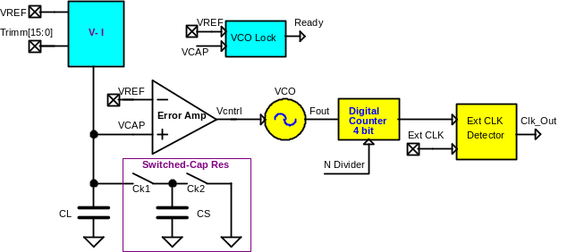
- Local Oscillator block diagram
The circuit was designed in a 180 nm Silicon-on-Insulator CMOS technology, using hardening by design techniques. A temperature coefficient better than 50 ppm/°C over an extreme temperature range of -40 to 125 °C has been achieved, with a 16MHz output frequency and after calibration, draining less than 10 mA from a 3.3 V source, as outlined in next table :
- Local Oscillator SImulation Results Summary.
Input Reference Voltage  [V] | Output Frequency  [MHz] | Analog Supply Voltage  [V] | Digital Supply Voltage  [V] | Current Consumption [mA] | Frequency stability [ppm] | Jitter [pS]
1.25 | 16 | 3.3 | 1.8 | < 10 | <5000 | <15
The Local Oscillator is at the schematic finalization stage.

POR IP
Power On Reset (POR) generates a reset signal when power is applied to the ASSP device. It ensures that the device starts operating in a known state [10]. POR includes unique features.
IP holds two independent POR blocks, one for 3.3V analog and one for 1.8V digital power domain. Both POR blocks include reference voltage source and comparator for accurate power supply voltage level and under-voltage condition detection. POR is compatible with power supply’s rise times from 10ns to 100ms. Internal delay ensures that POR state is always active at least 100µs. Under-voltage conditions shorter than 10ns are filtered out. POR is functional from -40°C to 125°C. Typical current consumption is 150µA.
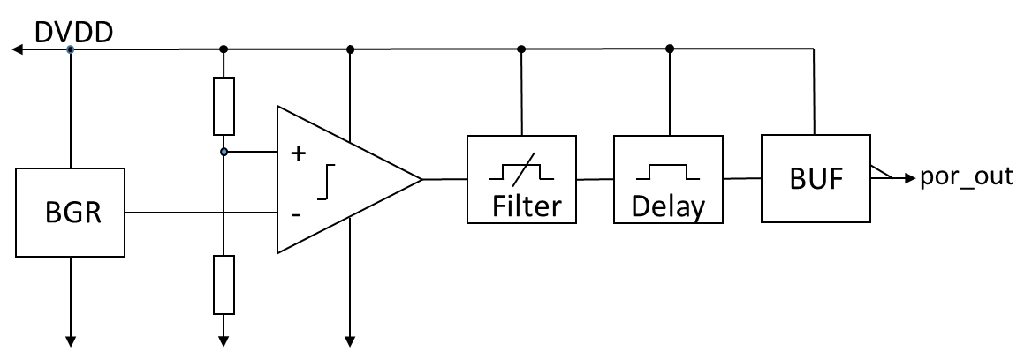
- POR 1.8V block diagram.
POR design is simulated and ready for layout phase.

Promise Project Status and Planned activity
The PROMISE project is in the IP and Pilot Circuit development phase. In early 2022 it expected to have all the IPs and the Pilot Circuit successfully passing the Critical Design Review before starting the manufacturing process. In parallel to these activities, the Test Board design and manufacturing phases will be conducted and the test setup will be prepared in order to ensure a smooth electrical and radiation qualification test campaign starting in mid-2022.

Conclusions
PROMISE project will generate a new ecosystem fully based on European suppliers and open to all the European Space Industry, as pursued by the H2020 work-program. PROMISE will enable the development of complete mixed-signal System on Chip solutions for the next generation of space data handling and data processing units. These units, in turn will become the core of new space missions for telecommunications, Earth observation or space exploration. The project results will be presented to all the community on an specific workshop planned for late 2024.
The new PROMISE based circuits will position European space industry on the front line of the development of low cost solutions oriented towards the ‘New Space’ paradigm. As a consequence, the European space actors will be able to take the leading role in the development, production and operation of satellite mega-constellations which are of paramount importance in the XXI century space development. This leading role, assumed without the burden of third party technological dependence, will foster the growth of the European space sector both inside and outside our borders and will generate high quality employment and technological leadership multiplying the return to the European citizens of the investment provided by this H2020 initiative.

References
- Max Maxfield. (2020, September). Eeek Alors! Radiation Hardened eFPGA IP, accessed May 8, 2021, https://www.eejournal.com/article/eeek-alors-radiation-hardened-efpga-ip/
- Adam Neale. Design and Analysis of an Adjacent Multi-bit Error Correcting Code for Nanoscale SRAMs. Waterloo, Ontario, Canada, 2014.
- G. Franciscatto, E. Geukens, G. Thys, S. Redant, Y. Geerts, M. Fossion, A. Van Esbeen. (2014, June). DARE180X: A 0.18µm mixed-signal radiation-hardened library for low-power applications. Presented at 5th International Workshop on Analog and Mixed-Signal Integrated Circuits for Space Applications (AMICSA 2014).
- D. Baramilis, K. Makris, A. Roumkou, E. Berlivet, A. Rantala, K. Tukkiniemi, C. Papadas, J. Beister (2021, May). Validation of an Analog Mixed-Signal Library (AMICSA 2021).
- D. Baramilis, E. Karaolis, P. Bampali, C. Papadas, E.Darakchiev, D. Levacq, M. Tourloukis (2018, June). Radiation Hardened Pulse Width Modulator in CMOS_SOI (AMICSA 2018).
- J. Calvillo, R. Póvoa, J. Guilherme, N. Horta, Second-order compensation BGR with low TC and high performance for space applications, in Elsevier’s Integration, The VLSI Journal, 63 (2018), 256-265.Y. Yorozu, M. Hirano, K. Oka, and Y. Tagawa, “Electron spectroscopy studies on magneto-optical media and plastic substrate interface,” IEEE Transl. J. Magn. Japan, vol. 2, pp. 740–741, August 1987 [Digests 9th Annual Conf. Magnetics Japan, p. 301, 1982].
- T. Vergine, M. De Matteis, S. Michelis, G. Traversi, F. De Canio, A. Baschirotto, A 65 nm rad-hard bandgap voltage reference for LHC enviroment, in IEEE Transactions on Nuclear Science, 63 (3) (2016), 1762-1767.
- T. Vergine, S. Michelis, M. De Matteis, A. Baschirotto, A 65 nm CMOS technology radiation-hard bandgap reference circuit, Ph.D. Research in Microelectronics and Electronics (PRIME), Grenoble, France, 2014
- D. S. Truesdell, A. Dissanayake and B. H. Calhoun, "A 0.6-V 44.6-fJ/Cycle Energy-Optimized Frequency-Locked Loop in 65-nm CMOS With 20.3-ppm/°C Stability," in IEEE Solid-State Circuits Letters, vol. 2, no. 10, pp. 223-226, Oct. 2019, doi: 10.1109/LSSC.2019.2946767.
- Huy-Binh L., Xuan-Dien D., Sang-Gug L., and Seung-Tak R. A Long Reset-Time Power-On Reset Circuit With Brown-Out Detection Capability. IEEE Transactions on Circuits and Systems II: Express Briefs ( Volume: 58, Issue: 11, Nov. 2011

