De / From: M. Fossion A. Van Esbeen |  | Date : 16/3/2022
 |  | Ref. : HMCU-ETCA-XR-2491
Subject : ESA AMICSA conference 2022 / paper submission abstract

TAS Belgium RadHard ASICS ( DPC and HSC) : Space applications – Maturity and Innovation

Alain Van Esbeen /Marc Fossion / Thierry Van Humbeeck from Thales Alenia Space Belgium
Christophe Delepaut / Arturo Fernandez / Richard Jansen from ESA

Introduction

Since more than a decade, Thales Alenia Space in Belgium is investing in a growing portfolio of RadHard ASICs with the Digital Programmable Controller as a flagship paving the way to other ASICs.
The brand new High Speed Controller, the” Swiss Knife for DCDC converters”, contains an innovative regulation , the Peak & Valley Current Control (PVCC)
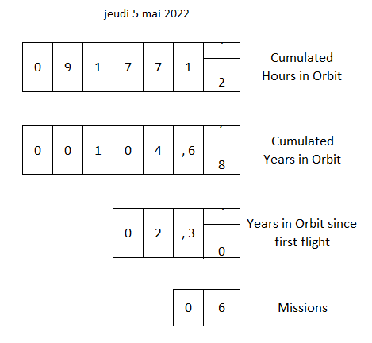

- Digital Programmable controller - Maturity
In previous publications during AMICSA workshops, TAS-B has explained the major steps of the development of the Digital Programmable Controller (DPC) , from die design to component qualification of the Ceramic ( CQFP) package.
This hermetic version is now flying since January 2020 with the following heritage counters:

This already impressive heritage is the result of massive usage of DPC inside Thales Alenia Space equipments, starting with GEO telecom satellites, immediately followed by Observation and science and exploration ( Exomars) missions. The footprint of the DPC is continuously enlarged thanks for instance to new development projects in the frame of Copernicus and Athena.

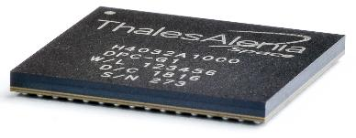
Recent development were focused on the low cost version with an organic BGA package. The formal qualification of this version is under finalization. This version is already largely used in many equipments of Space Inspire, the brand new satellite from TAS already sold to key customers and is a key component to address the Constellation market.

- High Speed Controller
The component includes all classical features required for the control of a dc-dc converter, allowing it to control a multitude of topologies.
- Current sensing amplifier with edge blanking, error amplifier and voltage reference
- PWM controller with 3 modes of operation: peak current control, average current control and finally also the innovative Peak & Valley current control (PVCC) proposed by ESA
- Various protections: over-current, over-temperature, over-voltage and under-voltage
- Reference oscillator with external synchro input.
Taking advantage of all the knowledge in organic encapsulation of the DPC, the HSC is now packaged in a BGA 11b*11b version.

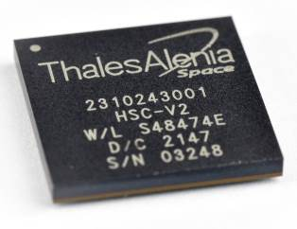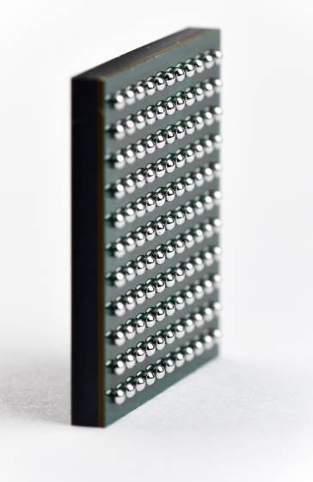

- Reconfigurable & high bandwidth regulation systems
New dc-dc converters in development are now embarking either DPC, or HSC or both in order to bring compactness, flexibility & optimized efficiency to these products.

The HSC in particular features a novel regulation scheme so called PVCC (Peak and Valley current control) developed by Christophe Delepaut and the ESA TEC team. Prototypes have demonstrated that current loop can now be pushed very nearby the Shannon limit (half of the switching frequency) as we speak about closed loop bandwidth. This represents an improvement of roughly a factor 2..3, specially for converters that have a large range (in & out voltages + output power) of operation. On its turn the voltage loop, that typically stays 3 times lower in closed loop bandwidth can be pushed much higher. The overall performance increase is significant: shorter transient response time and reduced output capacitor bank.

Flexibility is much easier to achieve thanks to digital control. The µC can sense multiple variables such as T°, input voltage, load current, … These parameters are injected to the regulation system (here mostly voltage control loop): the system aware of its environment can also be significantly optimized as compared to traditional blind regulation approaches. But where µC brings in most of its benefits is during transients phases such as start-up, shut-down and anomaly detection. Sequential operations can be programmed such as to manage the dc-dc during those transients resulting in a tightly controlled stress on the power components allowing to reduce the huge margins that were previously required.

Conclusion :

In the frame of a growing Rad Hard ASIC portfolio, a new branch of activities is now focused on GaN integrated circuit for power (Please refer to another dedicated AMICSA presentation from M. Fossion et al. , these 3 technologies (high bandwidth analog regulation + digital power management + GaN-ICs), constitute a key chipset leading to a complete breakthrough in dc-dc converters.
These key developments are made possible thanks to Multidomain skills in TAS B, an efficient network of innovative partners, a fruitful collaboration with ESA experts and a strong support from Belgian Delegation.

