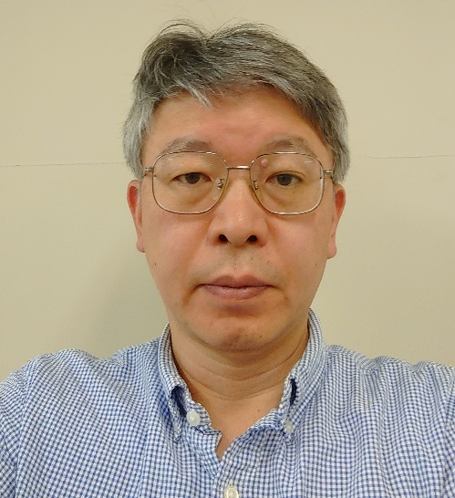

**Hideyuki TANNO received his Ph.D. degrees in Mechanical Engineering from Tohoku University in 2005. From 1996 to 1998, he studied scramjet combustor at the University of Queensland as a visiting researcher. He is a senior researcher in high-enthalpy shock tunnel JAXA-HIEST, a visiting professor in Tohoku University, and a board member of the Japan Society for Aeronautical and Space Sciences. He is mainly working on re-entry vehicles, scramjet, and Hayabusa1 and Hayabusa2 Japanese sample return missions.**