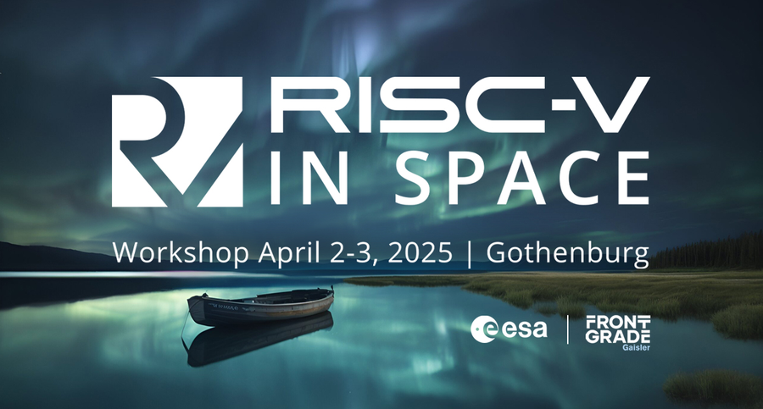

Dear student,

if you wish to apply for the ESA Students Sponsorship Programme, please provide the following information:

Student information:

* First name:
* Last name:
* Email:
* Age (number only):
* Gender (male/female/other) :
* Nationality:
* Level of Study (Bachelor, Master, PhD, other):
* Field of study (Science, Engineering, Legal, Business, other:…):
* University name:
* University country:
* Have you ever been sponsored by ESA? (Yes/No):
  + If you have, which activity/ies did you participate to?:
* Do you have less than 2 years of professional experience? (Yes/No):
  + If you have more than 2 years’ experience, who was your last employer:

Student contribution:

* What is the title of your contribution:
* Role (Author, co-author, other:… ):
* Will you be presenting your contribution individually (yes/no)

Student sponsorship request:

* Motivation to attend the conference (paragraph):
* Justification for ESA Academy sponsorship request (paragraph):
* Do you benefit from an overlapping financial support to attend this conference? (Yes/No):
  + If you do, please describe the other financial support:
* Do you agree with the with ESA [Academy's Privacy Policy](https://esamultimedia.esa.int/ESAAcademyPrivacyPolicy.pdf) (Yes/No):